**Macroeconomic Models for Assessing the Transition   
towards a Circular Economy: A Systematic Review**

**Abstract**

The Circular Economy (CE) paradigm has gained traction in both academic discourse and industrial practice. While a transition towards a CE is generally associated with more sustainable futures, less is known about its socio-economic feasibility. This article provides a systematic literature review of contributions to macroeconomic modelling which evaluate environmental and socio-economic impacts of CE interventions (classified in terms of closing supply chains, resource efficiency, residual waste management, and product lifetime extension). Differences in modelling approaches (Leontief input-output, macroeconometric input-output, and computable general equilibrium), and underlying assumptions relating to changes in final demand and technology, are found to be significant drivers of differences in the modelled outcomes of CE interventions. Through this review, various research gaps are identified, including addressing the challenges to sectoral and regional disaggregation (allowing for the modelling of international trade-offs), broader consideration of societal issues beyond GDP and employment (such as environmental, gender or transnational justice), and consideration of broader modelling dynamics (such as rebound effects, the interplay between demand and distribution, and real-financial interactions).

**Keywords:** Macroeconomic Models, Ecological Economics, Circular Economy, CGE, Computable General Equilibrium, input-output analysis, Macroeconometric.

**JEL Classification:** E16, E17, C67, D57

|  |  |
| --- | --- |
| **Table of Acronyms** | |
| ABM | agent-based modelling |
| CE | circular economy |
| CGE | computable general equilibrium |
| DSGE | dynamic stochastic general equilibrium |
| EEIO | environmentally extended input-output |
| FTT | future technology transformations |
| IO | input-output |
| SFC | stock-flow consistent |
| WIO | waste input-output |

**1. Introduction**

The Circular Economy (CE) refers to a set of strategies aimed at replacing linear modes of extraction and disposal with more sustainable modes of production and consumption (Calisto Friant et al., 2020). Proponents view the CE as a new paradigm capable of reconciling the interactions between the economy, society, and nature with restorative and regenerative systems, presenting a win-win from an economic perspective (Homrich et al., 2018). CE has recently gained traction among academics, practitioners, and policymakers, prompting a wealth of literature in the last decade (Genovese & Pansera, 2021). Moving beyond the sole pursuit of waste prevention and reduction, CE inspires holistic technological, organisational, and social innovation across and within supply chains. However, the macroeconomic literature still shows limited engagement with the structural change required for the CE transition (Boonman et al., 2023).

Consequently, the economic feasibility of a CE and the impact of CE-driven policies on socio-economic indicators, beyond GDP and employment, are underexplored, highlighting an urgent and major gap that to be addressed. Existing reviews in the literature include the important contribution of Aguilar-Hernandez et al. (2018), who survey how 93 environmentally extended input-output (EEIO) models describe CE strategies, while adopting a seminal typology for their classification (product lifetime extension, closing supply chains, resource efficiency, and residual waste management). McCarthy et al. (2018) present a (non-systematic) review of computable general equilibrium (CGE), and macroeconometric input-output (macroeconometric IO) models of CE interventions, with special emphasis on reported changes in GDP and aggregate resource extraction. McCarthy et al. (2018) also reflect on the difficulty of implementing several categories of CE policies in CGE models, coupled with the high variability of model outcomes depending on initial assumptions (especially regarding productivity growth, substitutability between different material types, and future consumption patterns). Noting the lack of attention in previous studies to the interaction between macroeconomic, social, and environmental impacts, Aguilar-Hernandez et al. (2021) present a sophisticated meta-analysis of modelled scenarios specifically focusing on GDP, employment, and CO2 emissions. Analysing 27 publications encompassing structural models (Leontief IO), macroeconomic models (macroeconometric IO, and CGE), and integrated assessment models, Aguilar-Hernandez et al. (2021) find that, despite heterogeneity, most of the literature reports *‘win-win’* results. In essence, the adoption of CE strategies is thought to be leading to a reduction in environmental pressures (e.g. GHG emissions or material extraction), combined with positive socio-economic outcomes (e.g. higher GDP and/or employment).

Absent in these previous literature surveys is an assessment of the critical role of the theoretical premises embedded in the different modelling approaches (for instance: whether output is demand-led or supply-led; the interaction between income distribution and economic growth). Further, they do not examine the underlying assumptions regarding the adoption of CE practices in the analysed scenarios (such as the complex trade-offs induced by changes in technology and final demand components). This paper complements these existing reviews, focusing on how estimated environmental and socio-economic impacts are affected by both the assumptions embedded in different modelling approaches, and the assumed changes in technology and consumption patterns associated with specific CE interventions. The limitations of reviewed modelling approaches are assessed, in order to indicate future avenues of research: namely, endogenous emergence and adoption of CE practices (Di Domenico et al., 2023), unsustainable accumulation of financial liabilities due to real-financial interactions (Godley and Lavoie, 2006), and transnational trade-offs linked to ecologically unequal exchange (Dorninger et al, 2021).

Our paper thus provides a comprehensive account of the current literature on macroeconomic models aimed at assessing the socio-economic impact of CE interventions. It focuses on model characteristics and CE strategies considered, highlighting the role of the underlying assumptions in driving scenarios results. As such, we seek to provide a critical guide for readers to navigate the literature, enabling them to better evaluate results reported in past and future papers. The paper is organised as follows. The methodology section reports how relevant papers were identified and selected. Section 3 provides a systematic literature review, covering: (i) a bibliometric analysis; (ii) an overview of the macroeconomic models found in the literature; and (iii) a review of the results obtained in the literature relating to different CE interventions. The main gaps in the current literature are identified in section 4, in order to suggest a research agenda. Section 5 contains some concluding remarks.

**2. Methodology**

A systematic literature review was conducted to identify key scholarly contributions to the macroeconomic assessment of CE interventions. The procedure is outlined in figure 1. PRISMA 2020 guidelines were used for reporting (Page et al., 2021). Initial source identification was performed through an abstract-title-keyword search within the SCOPUS and Web of Science databases, including all journal articles (excluding book chapters and conference proceedings) indexed up until September 2024. Search keywords are reported in table 1, categorised into ‘model’ and ‘CE concept’: the search logic was performed such that each result contained at least one ‘model’ and one ‘CE concept’ combined. This initial set of keywords was judged sufficient to cover a broad range of CE interventions and modelling frameworks, which were subsequently filtered systematically.

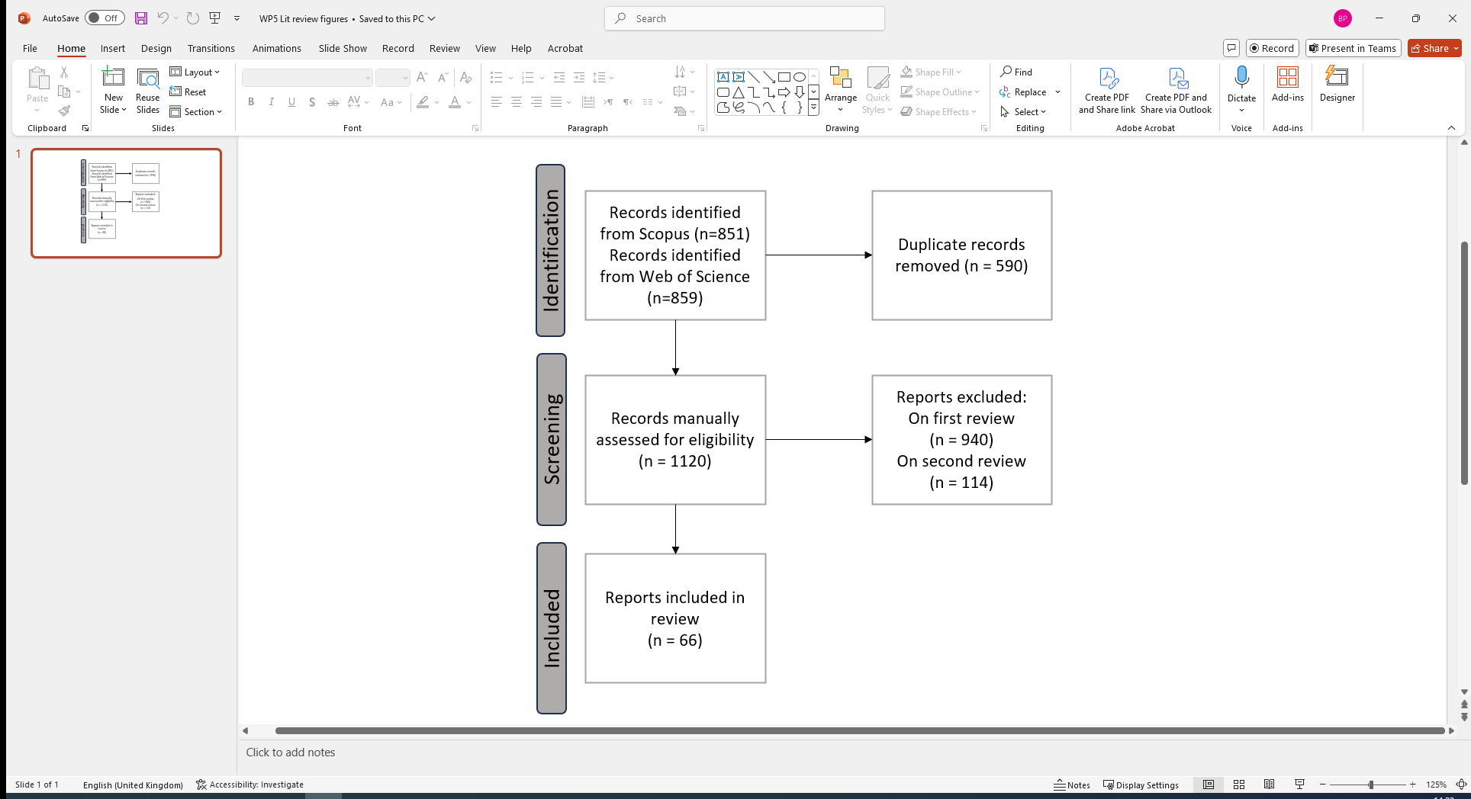

**Figure 1**: Flow chart of methodology.

|  |  |  |
| --- | --- | --- |
|  | **Concepts** |  |
| circular economy | residual waste management | recycling |
| closed loop supply chain | closing supply chains | remanufacturing |
| cradle-to-cradle design | product lifetime extension | industrial symbiosis |
| industrial ecology | resource efficiency | eco-industrial park |
|  | **Models** |  |
| input-output | computable general equilibrium | dynamic stochastic general equilibrium |
| stock-flow consistent | CGE | DSGE |
| macroeconomic model |  |  |

**Table 1:** Search keywords.

Once the subset of potentially relevant articles was identified (n = 1120), further refinement was performed on the abstracts: sources were excluded from the dataset unless they simultaneously verified the following criteria: (i) provision of an ex-post evaluation or ex-ante scenario analysis of a CE intervention; (ii) assessment of the impact of CE intervention on socio-economic and environmental variables (e.g. GDP, employment, prices, costs, profits, wages, greenhouse gas emissions, or material consumption). During this process, further criteria were developed to exclude documents that solely analysed the impact of carbon taxes or water usage. Based on these criteria, various papers were excluded from the dataset, such as those:

* providing an assessment of the impact of CE interventions solely based on environmental variables.
* analysing solely the co-evolution of environmental and economic variables to assess decoupling of emissions or material consumption, without identifying the effect of some CE interventions.
* focusing on micro- (e.g. single firm), or meso-level (e.g. supply chain, eco-industrial park) analyses, or at a sub-national scale, without developing macro-level considerations.
* not developing prospective scenario analysis of impacts of CE interventions based on multi-sectoral macroeconomic models.

A two-stage process was adopted to increase the reliability of the final selection. The 1120 papers were divided among the research team who reviewed article abstracts, with each paper reviewed independently by two members of the team. Papers were classified as *definitely* *meeting*, *maybe meeting,* or *not meeting* the eligibility criteria.

Papers classified as *not meeting* the criteria by both researchers were excluded in the first stage (n=940). If one of the two members classified the paper as *maybe* or *not meeting* the criteria, the paper was debated by all members in a meeting. Finally, the title and abstracts of all papers selected were reviewed by all members to ensure consistency in the final sample of selected papers, leading to a total of 114 papers excluded in this second stage. At the end, 66 relevant studies were selected, listed within Appendix A.

Basic attributes of each selected publication were analysed, recording the different CE strategies modelled, including the environmental and socio-economic variables covered, and other modelling characteristics: the type of table used to map intersectoral flows (input-output, or supply-use); the type of intersectoral flows (monetary, physical, or hybrid); the model object (diagnosis, scenario, or theoretical/methodological); the time dimension (single year, or multi-year), and the geographical scale (single or multi-regional, national or subnational). Different CE interventions are classified following the typology proposed by Aguilar-Hernandez et al. (2018), who categorise interventions into four different ‘intervention categories’ or ‘strategies’[1]: residual waste management, closing supply chains, product lifetime extension, and resource efficiency (table 2).

|  |  |  |
| --- | --- | --- |
| CE Strategies | Description | Key Interventions |
| Residual waste management | Related to post-consumption activities where the materials are disposed. | * Landfill * Energy recovery * Waste treatment |
| Closing supply chains | The re-integration of materials at different levels of the supply chain after being used, via for instance product reuse, component re-use, re- furbishing, and recycling. | * Reuse * Redistribution * Re-manufacture * Recycle |
| Product lifetime extension | Associated with slowing down the resource use as a consequence of extending lifetime of products, via for instance design for longevity, and improved maintenance. | * Delayed product re- placement * Maintenance * Repair |
| Resource efficiency | Processes or mechanisms which optimise resource flows by using less resources per unit produced. | * Material efficiency * Functional economy |

**Table 2:** Typology of CE strategies, adapted from Aguilar-Hernandez et al. (2018).

**3. Systematic Literature Review**

*3.1**Bibliometric Analysis*

The identified 66 papers can be classified across three broad modelling frameworks: (a) Leontief IO analysis with exogenous final demand determination (37 studies); (b) macroeconometric IO models with an econometric estimation of the evolution of final demand (6 studies); (c) neoclassical models, such as CGE models (19 studies). 4 studies use alternative methods which do not align to this categorisation.

Macroeconomic assessment of CE interventions, although still scarce, has become increasingly common, with at least one paper being published every year since 2011, and 49 out of the 66 papers published in this period. This growing interest can be related directly to increased concern from policymakers, exemplified by the adoption of the EU Circular Economy Action Plan in 2015, which has led to a flourishing of CE-focused research projects[2]. Additionally, the development of multi-regional IO databases that include environmental and material use extensions, such as EXIOBASE (Stadler. et al. 2018), and EORA (Lenzen, et al., 2013), have been instrumental in providing sectoral flow and associated impact data which have underpinned the development of macro- and meso-economic analyses of the environmental and socio-economic impact of CE interventions.

In terms of journals, few studies with socio-economic impact assessments of the implementation of CE interventions have been published in economics-focused journals. Figure 2 shows that the main exception is *Ecological Economics*, which has published 8 papers on the topic (5 based on Leontief’s IO model, 2 macroeconometric IO models, and 1 neoclassical CGE model). More concerning is that even *Economic Systems Research* (a journal owned by the International IO Association), has only one paper published on the topic. The main outlet for this line of research, beyond *Ecological Economics*, has been in journals that specifically deal with sustainability issues, such as *Journal of Cleaner Production* (11 papers), *Journal of Industrial Ecology* (5 papers), *Sustainability* (4 papers), and *Resources, Conservation and Recycling* (3 papers).

The most common socio-economic indicator category modelled in identified studies encompasses Value Added and GDP (37 papers), followed by employment (26 papers). Several works, primarily categorised as Leontief IO models, focus on production costs and/or prices (13 papers), and gross output (9 papers).

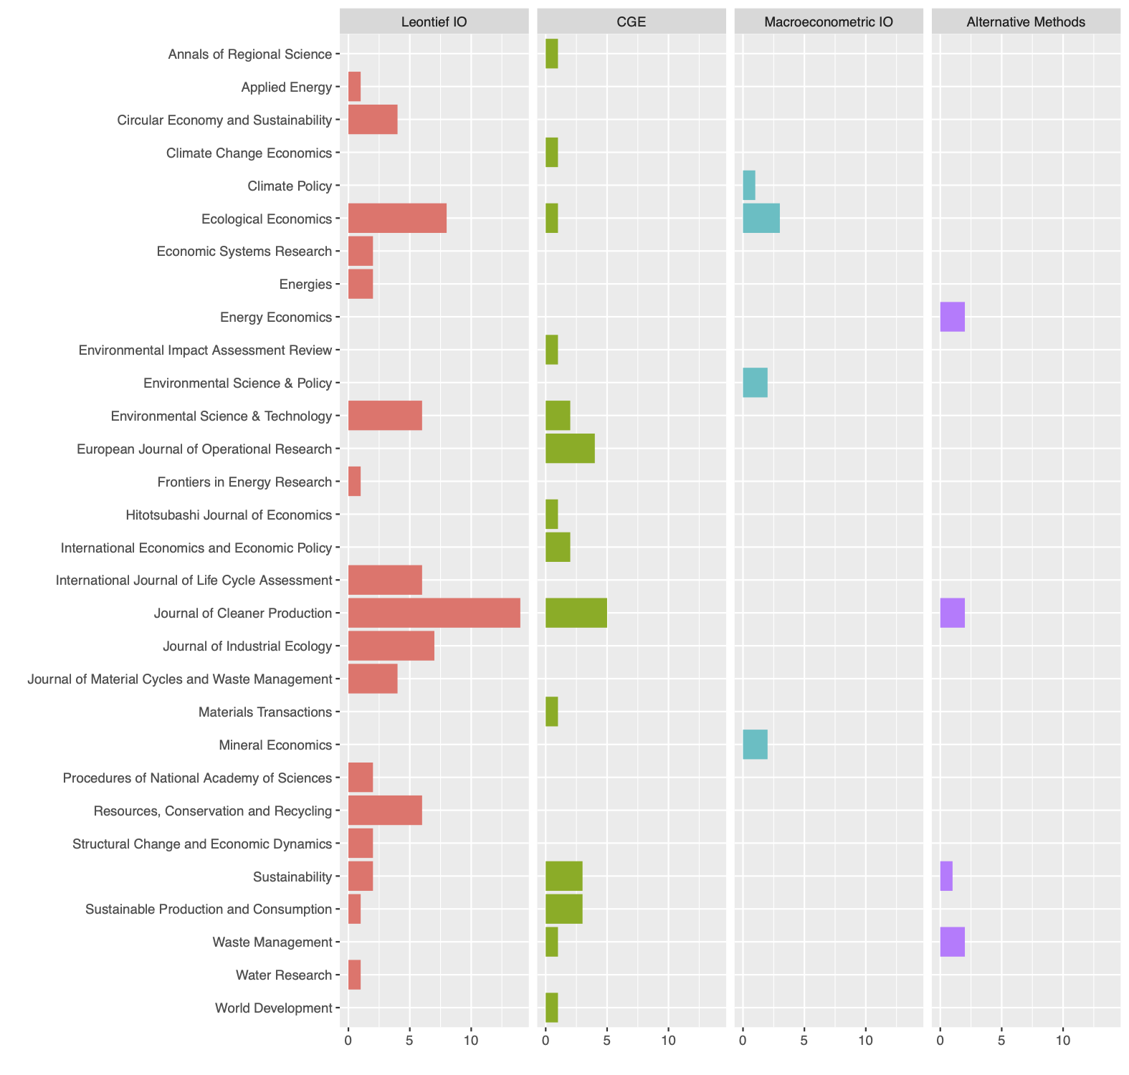

**Figure 2:** Distribution of identified sources in terms of the journal published in.

In terms of the CE intervention typology (table 2), closing supply chains was the most commonly modelled CE strategy (42 papers). 36 papers modelled resource efficiency interventions, and 23 modelled residual waste management interventions. The analysis of environmental and socio-economic impact of product lifetime extension appears to be underdeveloped (10 papers).

The four strategies used to classify the specific CE interventions modelled in each study are not mutually exclusive, i.e. a study can investigate the impacts of multiple CE interventions categorized into different strategies. This was the case in 35 out of the 66 papers considered. In particular, the most common overlap of modelled CE strategies was with closing supply chains and residual waste management (10 studies), largely due to recycling activities being categorised as closing supply chains. Hence, several papers that analyse the impacts of alternative methods of waste disposal (e.g. landfilling, incineration or recycling) are classified under both types of strategy (e.g. Nakamura and Kondo, 2002)[3].

Different modelling frameworks are applied unevenly to analyse the impacts of CE interventions, as indicated within figure 3. For instance, modelling of product lifetime extension has primarily been modelled using Leontief IO frameworks. This methodology also dominates the modelling of residual waste management interventions. The higher prevalence of the analysis of residual waste management interventions can be attributed to the development of waste input-output (WIO) analysis to analyse the impacts of alternative waste management options in Japan (see, for instance, Kondo and Nakamura, 2004; Nakamura, 1999; Nakamura and Kondo, 2002, 2006a, 2006b). Finally, macroeconometric IO models and CGE models have been mostly applied to the analysis of resource efficiency and closing supply chain interventions.

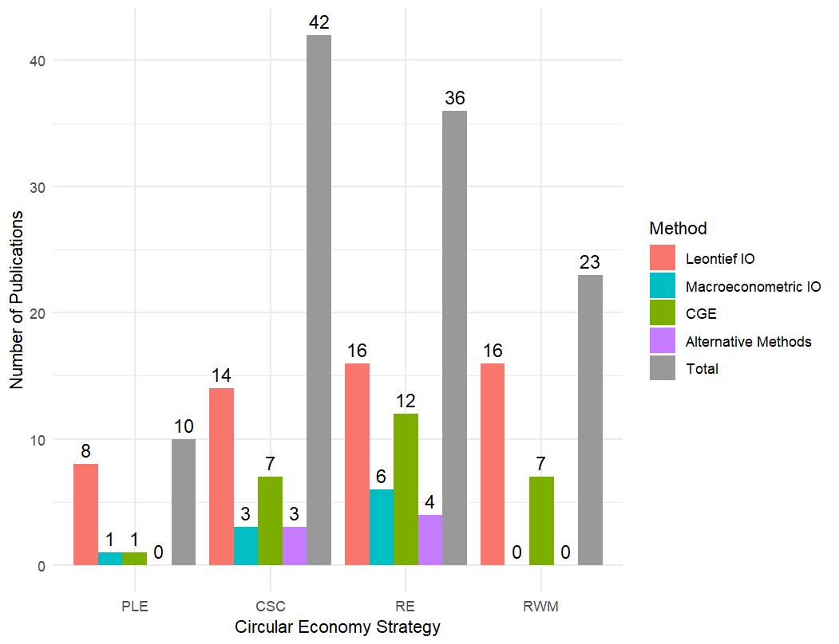

**Figure 3:** Number of publications classified by CE strategy and modelling method.

*3.2**Overview of Macroeconomic Modelling Frameworks*

In this section, we briefly discuss the features of the main macroeconomic modelling frameworks used to assess the impacts of CE interventions: Leontief IO, macroeconometric IO, and CGE models[4]. All approaches start from a multisectoral depiction of the economy based on IO tables, data regularly published by national statistic offices as part of the System of National Accounts (SNA, 2008).

Input-output (IO) tables describe transaction flows of goods and services, measured either physically or in monetary value, and track the destination of each sector-related output (Leontief 1966, Miller and Blair 2009). These outputs are sold either as inputs for other sectors (which demand them for production purposes), or they can be purchased as final products or services by households, firms, the government, and the foreign sector (in the form of private or government consumption, investment, and export). In short, IO tables capture the existing interdependencies between the different industries of an economy (or different regional economies).

Environmentally extended IO (EEIO) tables (Lenzen et al 2013, Stadler et al 2018) are obtained when IO tables are linked to environmental accounts tracking emissions, and material use (see Leontief 1970 for a pioneering contribution). Similarly, waste input-output (WIO) models (Nakamura 1999, Nakamura and Kondo 2002) extend these to consider physical waste flows. These extensions make it possible to analyse environmental impacts of changes in technology and final demand. EEIO analysis combines conventional IO tables expressed in monetary units coupled with satellite accounts detailing sector-specific variables that capture a wide range of environmental impacts, such as emissions, waste, extraction, use of water and land, and resource depletion, usually expressed in physical units. In contrast, WIO analysis exclusively focuses on waste flows and is thus mostly applied to study residual waste management. As such, based on the common dataset of IO tables, individual modelling approaches may adopt different model ‘closures’ (i.e. choices of exogenous variables) and behavioural functions (representing the interactions among economic agents that determine the model’s endogenous variables).

*3.2.1 Leontief IO models*

The most frequent approach is the ‘open’[5] Leontief IO model (Leontief, 1944), which computes total output, value-added (GDP), employment, and environmental footprints associated with given levels (and sectoral composition) of final demand and available technology[6]. This approach is helpful for investigating potential environmental and socio-economic impacts of exogenous changes in the level (or in its sectoral composition) of final demand components, such as in consumption, investment, government spending levels, or changes in technology of production (Leontief, 1970; Wiedmann, 2006).

This framework has been used in seminal contributions to industrial ecology. Duchin (1990, 1992) sets out a framework for formally analysing flows of biological products and waste as additional IO sectors in the social accounting matrix. This enables quantification of changes to residuals, unit prices, pollutant treatment costs, or national income. By treating waste not only as an output but also as an input (i.e. recycling), this approach was later developed into the WIO framework by Nakamura (1999). In one important application, Nakamura and Kondo (2002) estimated hybrid-unit IO tables for Japan with 80 goods-producing sectors, 10 waste treatment methods (incineration with different mechanisms of energy recovery, shredding, composting, gasiﬁcation, and landﬁlling), and 40 waste types. Ferrer and Ayres (2000) develop a framework for analysing the adoption of remanufacturing practices using monetary IO tables, in which each sector is split into two, such that each type of good can be produced either by the original manufacturing sector or a remanufacturing sector. More recent contributions (e.g. Wiebe et al., 2019; and Donati et al., 2020) have focused on monetary EEIO tables to analyse wider sets of CE interventions.

The Leontief IO model relies on some fundamental assumptions: (i) constant returns to scale (i.e. technical coefficients do not depend on production scale); (ii) no possibility of substitution between factors of production (labour, capital and land) or between inputs; (iii) each sector produces only a single homogeneous product, with only one technology; (iv) changes in prices do not affect final demand (i.e. price-elasticity of demand is nil); (v) no supply constraints of labour, capital, and natural resources, and no financial constraints (Miller and Blair, 2009, ch. 2)[7].

The computational simplicity of Leontief IO allows detailed analysis of CE interventions at high sectoral and regional disaggregation, something critical given the sector-specific nature of technological changes and the importance of understanding cross-border impacts. For instance, De Boer et al. (2021) finds that the introduction of CE strategies in Belgium leads to increases in employment and emissions domestically, but reduces both globally. Nevertheless, Leontief IO’s lack of supply constraints may produce implausible socio-economic impact assessments for large shocks (ILO, 2024). The assumptions of fixed prices, technical coefficients, and exogenous final demand ignore rebound effects[8] associated with changes in relative prices and income. While ‘closed’ or dynamic versions of the model could address these limitations, these are largely absent in the literature (except Pauliuk et al. 2015). Such limitations are partially addressed through macroeconometric IO and CGE methodologies, discussed in the next subsections.

*3.2.2 Macroeconometric IO models*

The macroeconometric IO framework was pioneered through the model of the UK economy developed by the ‘Cambridge Growth Project’ (Cambridge, DAE 1962), and the INFORUM model for the US of Almon et al. (1974). In contrast to Leontief IO models, the level and composition of final demand components (household and government consumption, investment, and exports) are not exogenous but determined through behavioural equations whose parameters are econometrically estimated (Kratena and Termusho, 2017), as in Wiebe et al. (2023). Macroeconometric IO models can be categorised as dynamic models due to their capital stock adjustment, and inclusion within their behavioural equations of lags which describe reaction of the system to changes in prices and income levels, associated with the initial modelled policy shock. Such contributions can capture important dynamic impacts, such as rebound effects on environmental and socio-economic variables associated with CE interventions that are not possible with the ‘open’ Leontief IO framework.

Early macroeconometric IO models defined total output using a standard Leontief (quantity) IO model once final demands were econometrically determined for each sector. Over the decades, the treatment of supply has grown in sophistication, for example Meyer et al. (2012) endogenize changes in technical coefficients by incorporating time trends and relative cost effects. Firms set their prices based on a fixed mark-up rule, in line with oligopolistic pricing. Labour market variables (such as hours worked, employment, and participation rate) are dependent on (estimated) real output and the real wage (among other variables), following functional relationships derived econometrically.

In the literature reviewed, Pollitt et al. (2020) uses the E3ME model, featuring 61 regions and 70 sectors, to analyse the impact of a materials tax on the consumption of steel, cement, and aluminium over the period 2020-2050. Meyer et al. (2007, 2012) developed the PANTA-RHEI for Germany, which has 59 sectors, to analyse the environmental and socio-economic impacts of increased material efficiency achieved by higher R&D expenditure and through resource taxes. In turn, Giljum et al. (2008) and Distelkamp and Meyer (2019) apply the multi-regional model GINFORS, which has 39 countries-regions and 35 sectors, to study the effect of increased resource efficiency, and metal recycling rates respectively.

Overall, macroeconometric IO models tend to be optimistic about the possibility of achieving decoupling between economic growth and emissions/resource use, even when accounting for rebound effects. The demand-driven nature of these models implies that the investment in new technologies associated with CE interventions will always tend to stimulate economic growth, at least during the transition phase. Moreover, CE interventions that have been investigated in the reviewed papers normally involve an increase in material efficiency. On closer inspection, what is being modelled is an increase in productivity which, when coupled with the assumption of fixed mark-ups, is passed-through to prices. This, in turn, stimulates final demand, both directly (price effect) and indirectly (income effect). Similarly, increases in recycling are associated with higher expenditures and employment requirements (relative to other forms of residual waste management). However, other CE practices, such as product life extension or functional economy practices (not considered, so far, in applications using this framework), are likely to be much less effective in terms of output and employment generation.

Macroeconometric IO models are flexible enough to allow the modeller to define different behavioural equations using different explanatory variables and theoretical frameworks (e.g. Keynesian or neoclassical). However, in reviewed applications consumption and production decisions are not directly derived from constrained utility or profit maximization problems solved by ‘perfect’ rational representative agents, as is in CGE models. Nor do they tend to assume perfect competition in markets. Instead, economic agents are modelled to act in oligopolistic markets under conditions of bounded rationality. As such, although supply adjusts to demand, there is no underlying assumption of a tendency towards full-employment in the long-run, as occurs with CGE models following a neoclassical ‘closure’.

On the one hand, this yields scenario projections based on assumption which can be considered more in accordance with observed reality. However, these models are w subject to the Lucas (1976) critique, which argued that the econometric estimated parameters of those models were not ‘structural’, i.e. not policy-invariant. As such, the estimated parameters would necessarily change, as rational agents adapt, such as when new CE policies are introduced. Thus, Lucas (1976) argued that ‘deep parameters’ (relating to preferences, technology, and resource constraints), that are assumed to govern individual behaviour (the so-called ‘microfoundations’), should be explicitly modelled, which is what is done in the CGE literature.

*3.2.3 Computable General Equilibrium (CGE) models*

Pioneered by Johansen (1960), CGE models combine IO tables with other datasets (e.g. household and labour market surveys) to provide an economy-wide picture of the economic relationships between different economic agents in a multi-sectoral setting. In contrast to macroeconometric IO, CGE models determine final demand and production decisions by firms following a bottom-up approach, tracing back the behaviour of each final demand component to an individual rational representative agent (households, government, firms) who maximises their objective function (respectively, utility, welfare, profits) subject to a budget constraint. In similar fashion, production decisions in each sector are taken by a representative firm seeking to maximise profits, subject to available technology and factors of production costs (Burfisher, 2021).

Following a shock in one or more exogenous policy variables, CGE models are solved to achieve a unique and socially optimal equilibrium level of GDP, which is normally dependent on exogenously given rational individual preferences and supply-side variables, such as initial endowments of factors of production (labour force, capital, and natural resources), and technology. Hence, in CGE models, output is considered to be supply-driven (i.e. demand adjusts to supply of output), as opposed to demand-driven Leontief IO and macroeconometric IO models.

Despite the basic similarities arising from the common framework, individual CGE models can differ significantly from one another depending on: (i) model closure; (ii) the form of the production and utility functions, and associated values of elasticity of substitution; (iii) whether the model adopts a static, recursive dynamic, or dynamic intertemporal approach; (iv) geographical coverage (single-country, multi-regional) and associated trade elasticity. These characteristics are of crucial importance for the impacts of CE strategies estimated by each model[9].

In CGE modelling, ‘model closure’ refers to the critical choice of which variables are treated as exogenous (determined outside the model), and which are endogenous (determined within the model). This choice is crucial because it aligns the model with specific theoretical perspectives (e.g., neoclassical or Keynesian) and significantly influences the results of policy simulations (see Taylor, 2016; Alderman and Robinson, 1989). While CGE models offer the flexibility to adopt diverse closures, most of the reviewed studies, with the notable exceptions of Skelton et al. (2020), and Ross et al. (2023) in their treatment of the labour market, employ neoclassical closures. This generally entails assumptions of perfect competition in goods and labour markets, flexible prices and wages (with exogenous labour supply), savings driving investment, government expenditure adjusting to meet a pre-set deficit/surplus target, and a flexible exchange rate balancing the current account. These assumptions lead to a model equilibrium characterized by full employment and full capacity utilization, where output and employment converge toward a unique and optimal outcome, determined by supply-side variables (e.g. population and productivity growth).

The choice of closure has a considerable impact on the adjustment process after a shock, such as those associated with CE interventions, affecting estimated impacts. Despite the importance of this choice, Ross et al. (2023) is the only study in our selection which explores the results of CE transition scenarios using alternative closures. Specifically, they demonstrate that the effects on employment and GDP become more negative under a fixed nominal wage closure compared to a bargained real wage closure, where real wages are dependent on the unemployment rate. Their result is in contrast with the results of similar costless resource efficiency shocks obtained by Schandl et al. (2016), Hatfield-Dodds et al. (2017), and Nong et al. (2023), highlighting that the assumption of labour market equilibrium can be crucial to estimated results.

The functional forms of utility and production functions, and particularly the elasticity of substitution, can also significantly impact CGE model results. The elasticity of substitution governs how easily firms and consumers can switch between inputs or goods when relative prices change, while maintaining a certain level of output or utility. A zero elasticity implies no substitutability (goods and inputs are perfect complements), whereas an infinite elasticity means perfect substitutability. This parameter is critical for CE interventions aimed at, for example, promoting recycled materials or remanufactured products. Higher elasticity values amplify the impact of CE interventions that make CE alternatives relatively cheaper.

It is crucial therefore that authors disclose the assumed values for elasticity of substitution and conduct sensitivity analyses to gauge impact on results. For instance, Brusselaers et al. (2022) demonstrated that reducing the elasticity of substitution between household appliances and repair services from 3.35 to 0.9 can lead to a 5.16% decrease in repair service consumption, depending on the policy scenario analysed. This highlights how significantly the substitutability between inputs or final goods assumptions influence the simulated impacts of policies related to CE.

CGE models also allow for the substitution between domestic and foreign inputs (goods), the ‘Armington elasticities’ (Armington, 1969), typically assumed to be imperfect substitutes. The specific values used for these elasticities can vary across models, leading to significant differences in estimated ‘leakage effects’ of similar CE interventions by different models. For instance, a higher Armington elasticity implies that local environmental taxes on production (e.g. taxing plastic made from crude oil) might lead to a greater increase in imports of plastic products, effectively shifting production and emissions elsewhere rather than reducing them overall. If combined with low elasticity of substitution in production between virgin and recycled materials, then this leakage effect may be magnified. However, many reviewed papers lack detail on these assumptions or fail to conduct sensitivity analysis related to the Armington elasticity values.

Within the CGE models reviewed, a static approach is often followed, like Leontief IO models, in which the (non-shocked) exogenous variables determining the equilibrium are kept constant. This is seen in waste management policy evaluation in Japan (Okushima & Yamashita, 2005), the transition from end-of-pipe waste treatment to resource management in Sweden (Ljunggren Söderman et al, 2016), the environmental benefits of subsidies to engine remanufacturing in China (Peng et al, 2019), and fiscal policies in support of lifetime extension through repair activities of household appliances in Belgium (Brusselaers et al, 2022).

Other applications, use a recursive (Dixon and Rimmer, 2002), or intertemporal (McKibbin and Sachs, 1991) dynamic approach where the economy adjusts to a new equilibrium at each time-step iteratively or over the whole time period, with exogenous variables changing over time. However, the computational requirements of economic equilibrium at each time-step limits the analysis of the transitional dynamics of CE interventions. Dynamic CGE models reviewed are mostly recursive rather than intertemporal, as the latter are very complex and computationally expensive. Recursive applications include Japanese waste management policies, including higher investment and technological innovation, taxation reform to introduce waste power generation, and changes in consumption patterns (Masui, 2005); resource efficiency in the whole steel supply chain at the global level, ranging from mining, primary and secondary production, to steel scrap recycling (Winning et al, 2017), the double dividend accrued from the economic and environmental effects of environmental fiscal reform on 31 pollutant emissions in Spain (Freire-González & Ho, 2018), and the role of sector emission targets for the steel in the context an international cooperation agreement and their interaction with emissions trading systems and competitiveness (Duscha et al, 2019).

CGE models have been used to capture feedback effects between the environment and the economy by integrating economic models with climate change, energy, waste, and other ecological modules, resulting in Integrated Assessment Models (IAMs). Examples include Ljunggren Söderman et al. (2016), Schandl et al. (2016), Hatfield-Dodds et al. (2017), and Shih et al. (2024). Shih et al. (2024), for example, integrates a ‘future technological transformations’ (FTT) module (Mercure et al., 2012) with a WIO model to endogenously determine waste treatment shares by technology based on demand for recycled goods and carbon taxes. However, IAMs have faced criticism for their complexity, lack of transparency, and high sensitivity to model assumptions, particularly regarding discount rates and climate-damage functions (Pindyck, 2013; Stern, 2021; Stern and Stiglitz, 2021, 2022; Purvis, 2021).

Overall, CGE models are powerful tools for analysing economy-wide impacts of several economic policies. However, the neoclassical framework, on which all the CGE models reviewed are based, has been criticized for its unrealistic assumptions regarding perfect competition in markets (Robinson, 1969; Shaikh, 2016), rational optimising behaviour of agents (Alchian, 1950; Simon, 1978), flexibility of prices and wages (Tobin, 1993), money neutrality (Mercure et al., 2018), and the lack of representation of the financial side (Godley and Lavoie, 2006), among others. Alternative behavioural assumptions can be used to ‘close’ the model, in the Keynesian and structuralist traditions (Taylor et al., 1990), which reverse economic causality implied by the model to a demand determined equilibrium. These behavioural assumptions, such as oligopolistic price-setting competition in the form of markup pricing, autonomous effective demand, lead to non-market clearing equilibria in labour and commodity markets (Taylor & Von Arnim, 2007). Moreover, results are sensitive to choice of unobservable behavioural parameters, such as the elasticities of substitution, whose empirical validation is hard to verify. In regards, specifically, to CE applications, computational complexity of CGE’s necessitates higher aggregation of sectors and regions relative to the Leontief IO and macroeconometric IO models, leaving results more vulnerable to aggregation bias, and neglecting uneven regional effects.

*3.3**Modelling CE interventions: an Overview*

Interventions associated with different CE strategies might be modelled in different ways within the IO table, with some involving adjustments in the technical and/or final demand coefficients, and others requiring splitting and/or extending sectors. Other interventions require the incorporation of data expressed in hybrid units. In this section, we review the methods and assumptions through which CE interventions are modelled, categorising modelled CE interventions according to Aguilar-Hernandez et al.’s (2018) typology.

*3.3.1 Product lifetime extension*

This strategy encompasses interventions that slow down resource depletion by lengthening the useful life of a product, e.g. changing the way products are designed, improving resistance of materials and components, and facilitating maintenance and repair. Significantly, aside from Masui (2005), such interventions have been examined through Leontief IO models (8 studies), with applications including electric home appliances (Kondo and Nakamura, 2004), the automotive sector (Kagawa et al., 2008; Walz, 2011), machinery and equipment (Wiebe, 2019), and metal and electric products (de Boer et al., 2021).

Donati et al. (2020) provide a more comprehensive study using EXIOBASE to assess the potential benefits and drawbacks of several product lifetime extension policies, including extending average lifetime of buildings, vehicles, and electrical machinery sold to final consumers. Here, an increase in demand for repair and maintenance services is assumed to compensate for a lower final demand for goods. Compared to other CE policies modelled by Donati et al. (2020), product lifetime extension interventions produce the largest reduction in emissions, GDP, and employment.

In general, product lifetime extension interventions are likely to lead to significant changes to both final and intermediate demand flows in each sector. While all studies record positive effects on environmental variables, findings are mixed in relation to impacts on socio-economic variables. Divergent economic effects are observed, with the outcome depending on the relative magnitude of each intervention: if goods last longer, final demand for them reduces.

This direct effect may be (partially) offset by two indirect effects. First, a higher amount of material input per unit of physical output might be necessary to increase the lifetime of products; causing an increase in technical input-output coefficients. Hence, whilst a lower final demand might reduce material consumption, the associated change in product design can result in a higher demand for materials. Secondly, product lifetime extension interventions increase final demand for maintenance and repair services. These services still require material inputs, although likely less than the production of brand-new products. Additionally, the associated shift in final demand (from manufacturing sectors to repair) can affect relative prices.

In relation to assumptions regarding final demand for repair and maintenance services, some studies keep this constant in absolute terms, such as Wiebe (2019), and the ‘product lifetime extension with functional upgrading’ scenario in Kondo and Nakamura (2004). Other studies assume that repair and maintenance services only increase proportionally, such as Donati et al. (2020), and the ‘product lifetime extension with no-functional upgrading’ scenario in Kondo and Nakamura (2004). As a result, the socio-economic results of these interventions considerably differ depending on how their impact on final demand is modelled.

Employment might increase if total final demand is kept constant in absolute terms, given the higher labour-intensity of repair and maintenance services compared to the manufacturing sector. However, as Kondo and Nakamura (2004) observe, a constant final demand may imply an unrealistic demand increase in the repair and maintenance sector. On a more realistic note, Wiebe et al. (2023), working across five consumer goods supply chains (electronics; textiles; construction; plastics; metal products) report on the positive impacts in Norway of product lifetime extension, resulting in increased employment and decreased imports, which potentially leads to lower emissions. Yet, they recognise potential negative impacts on employment at a global level.

*3.3.2 Closing supply chains*

Closing supply chains strategies imply the reintegration of materials at different levels of the supply chain after being used, via for instance product reuse, component reuse, refurbishing, and recycling. 42 papers, dealing with recycling, reuse, and remanufacturing strategies are included in this category, presenting several modelling challenges.

First, sectors need to be disaggregated depending on the usage of primary or secondary sources, making assumptions about technical and labour coefficients crucial. Second, the model may assume an unlimited supply of secondary raw materials, or this can be linked back to waste production through a WIO model.

Further, recycled materials are not always perfect substitutes of primary ones due to downcycling effects; as such, prices of secondary goods may be a fraction of those original ones. Estimates of this price reduction varies significantly across different studies, leading to issues with the distribution of savings associated with a lower cost of remanufactured inputs among profits and prices. Furthermore, changes in relative prices and disposable income may have an impact on final demand. Despite different assumptions, all studies assume that remanufactured products are more labour intensive than the original ones due to lower automation of closing supply chains activities.

A few early IO-based contributions define alternative approaches for closing supply chain interventions: Ferrer and Ayres (2000), Nakamura (1999), and Nakamura and Kondo (2002), which expands on Duchin (1990, 1992). Using a 30-sector model for the French economy, Ferrer and Ayres (2000) evaluate the impact of an increase in remanufacturing activities on material consumption and employment. The authors split each sector into two sub-sectors, based on the source of raw materials (primary or secondary). The two sub-sectors produce the same final output through their own technical and labour coefficients. In general, remanufacturing industries require less inputs from other industries, modelled through lower technical coefficients $,$ compared to traditional industries. However, some technical coefficients may be higher, namely for transportation services (due to the complexity of reverse logistics) or labour requirements (as scale advantages are not always possible in remanufacturing). In addition, manufacturing industries might need to provide additional inputs to the remanufacturing sector. Thus, while the direction of change in coefficients can be established qualitatively in a straightforward manner, determining its magnitude may be challenging. This may lead to different environmental and socio-economic results, requiring empirical qualitative and quantitative studies for validation of changes assumed.

From a demand perspective, similar issues to the ones found with product lifetime extension appear. Ferrer and Ayres (2000) assume that the original final demand (in physical terms) is split between the remanufacturing and the original manufacturing sectors. This implies a fall in monetary final expenditure, considering that alternative goods produced by the remanufacturing sector are delivered to consumers at a reduced price. Instead of assuming that income in monetary terms falls concomitantly (as in a neoclassical general equilibrium framework) Ferrer and Ayres (2000) assume a constant final demand and then redistribute the increased disposable income proportionally to all sectors.

Overall, results show that interventions aimed at closing supply chains tend to have positive socio-economic impacts, with an increase in GDP and employment, and a decrease in environmental impacts at a global level, independently of the modelling framework adopted.

A noteworthy case is presented by Gue et al. (2022), who introduce a 16-sector EEIO model to simulate CE strategies mainly concerned with supply chain issues (such as the implementation of circular business models and servitisation). Their results show a potential of up to 10.05% increase in GDP and 62.51% decrease in material footprint compared to a business-as-usual scenario for the economy of the Philippines.

In papers disaggregating results into regional impacts, such as Fuse and Kashima (2008), Winning et al. (2017) and Nechifor et al. (2020), results are more nuanced. Nechifor et al. (2020) for instance show resulting impacts which are unevenly distributed, with negative effects for major iron ore exporters from the Global South. This is supported by the study from Martínez-Hernando et al. (2024), who looks at the potential of the secondary production of platinum, through supply chain interventions; through an multi-regional EEIO approach, results show that secondary production of platinum in Europe causes a substantial drop in CO2-eq emissions (-100.9 %); however, impacts in terms of labour hours are negative (-78.9%), mainly affecting Global South countries.

In general, estimates of employment increases are linked to the assumption that remanufacturing, recycling, and reuse of goods are more labour intensive than the original manufacturing process. This, however, comes with a fall in labour productivity at the aggregate level, which may negatively impact firm profitability. Hence, to guarantee the economic viability of CE interventions for profit-driven firms, the difference in material costs must offset potential higher labour costs[10]. A corollary is that different models of firm ownership (e.g. private, collective, or public) may show significantly different speeds in the adoption of CE strategies. Most papers do not take into consideration price dynamics to determine the adoption rate of closing supply chains. Even in macroeconometric IO and CGE models, rates of recycling and demand for remanufactured goods in secondary production are exogenously set, mainly based on climate targets. The use of a FTT model to endogenously determine the shares of waste going to recycling by Shih et al. (2024) provides an interesting exception.

*3.3.3 Resource efficiency*

Resource efficiency interventions (36 studies) aim to reduce material consumption in the production process by using fewer resources per unit of output. These include scrap diversion, yield loss reduction, process improvements, and use intensification. Functional economy initiatives, such as shared use of products among final consumers (e.g. car clubs), are also included here. We also classify within this category papers analysing the impact of changes in tax rates intended to induce a reduction in resource use per unit of output.

In terms of modelling this category of CE interventions, technological changes that increase material efficiency in production can be represented as a reduction in technical coefficients (see, for instance, Cimpan et al., 2023). Different studies, however, make varying assumptions regarding whether material efficiency gains can be obtained without any additional expenditure in other services, such as consulting or research & development, or higher investment in fixed capital.

Meyer et al. (2007) simulate the effect of a linear increase in material efficiency in production in Germany over a period of 11 years, causing an increase in expenditure in consulting costs and investment in fixed capital worth six years in material cost savings. Wiebe et al. (2019) assume that reduction in material costs are completely offset by increased research & development expenditure, thus keeping total demand constant. Donati et al. (2020), who do not include any compensating increase in technical coefficients from consulting or increased investment, find a negative impact on modelled socio-economic variables considered. In contrast, Meyer et al. (2007) and Wiebe et al. (2019) find positive impacts. An unexpected result given that all three models share a common demand-driven approach, highlighting once again that differences in assumptions regarding changes in technical coefficients associated with the CE intervention can alter direction of results.

In supply-driven CGE models, costless material efficiency gains would be expected to stimulate economic growth and employment due to lower prices. For example, Hatfield-Dodds et al. (2017)[11] model a reduction in the raw material required in several sectors ( forestry; non-metallic minerals; iron and steel; non-ferrous metals; chemicals, rubber and plastics) which, in isolation, would lead to a 8.8% increase in GDP relative to the baseline. However, the macroeconomic ‘closure ’rules adopted are important. Contrary to Hatfield-Dodds et al. (2017), Ross et al.’s (2023) modelled closure allows for the emergence of involuntary unemployment and find small negative socio-economic impacts of a costless 15% decrease in intermediate input use by the construction sector (between -0.16% and -0.86%, in terms of employment, and between -0.23% and -0.98%, in terms of GDP).

Like previous categories, a second key issue concerns the redistribution of cost reductions due to material efficiency. Overall, CGE models, such as Skelton et al. (2020), assume a full pass-through of cost savings to prices in line with the assumption of perfect competition. Other approaches, such as the macroeconometric IO models proposed by Giljum et al. (2008), Meyer (2012), and Distelkamp and Meyer (2019), derive only a partial pass-through from econometric estimations. In contrast, the canonical Leontief IO model assumes fixed prices, so that cost savings lead to an increase in the value added per unit of output, i.e. an increase in the profit rate and/or real wages.

Nevertheless, some papers (e.g. Skelton and Allwood, 2013) keep the value-added coefficients constant and calculate the associated potential changes in prices due to increased material efficiency. Considering that most applications use the ‘open’ Leontief IO model, the assumption regarding changes in prices, wages, and profits, bears no consequence for the estimates of environmental and socio-economic impacts. The study from Pfaff and Sartorius (2015) is an exception, providing one of the few estimates of rebound effects arising from this reduction in prices due to increased material efficiency. However, it estimates the material rebound to be only 3.8%, much lower than in CGE and Macroeconomic IO studies, which the authors attribute to not capturing substitution and growth effects.

The modelling of functional economy interventions primarily involves changes in the composition of final demand. In general, use intensification leads to a shift in final consumption expenditure from the purchase of durable goods to the purchase of services provided by asset-owning companies. Some other ancillary changes might be considered, such as increased initial investment by service firms, or an increase in expenditure on repair and maintenance of durable goods. Regarding these issues, there is agreement on the direction of changes, though estimating their relative magnitudes is more challenging.

Most applications regarding sharing economy interventions relate to the use of automobiles. Results present minor socio-economic impacts: in some cases positive (e.g. 20,000 jobs created in Walz, 2011; 5,000 jobs in Cooper et al., 2016), in others negligible (-0.01% jobs in Skelton et al., 2020), and in some negative (-0.3% jobs in Donati et al., 2020). Moreover, Skelton et al. (2020) find up to 85% of emissions reductions are offset by economy-wide rebound effects.

Most CGE studies analyse the impact of environmental taxes aimed at stimulating shifts in consumption and production patterns leading to higher resource efficiency. Schandl et al. (2016) analyse the impact of different global carbon prices on GDP, CO2-eq emissions, and material consumption. Increased energy costs, due to the increased global carbon price reduce the consumption of energy-intensive goods. However, this also creates an incentive for investments in green technologies, partially offsetting negative socio-economic impacts. Overall, GDP would 1.6% lower than in the business as usual scenario.

Hatfield-Dodds et al. (2017) simulate the impact of a resource extraction tax. When implemented in isolation, this measure results in a lower global GDP (-4.2%) relative to the existing trends, while resource extraction is 6.4% lower. However, when coupled with assumptions of an increase in resource efficiency a ‘win-win’ scenario is observed, in which GDP is 5.6% higher and global resource extraction is 17% lower in 2050 relative to the business as usual scenario. This result is a consequence of the assumption that cost reductions are passed-through to lower prices, and consumers are assumed to increase their savings, rather than increase consumption. Under the model’s neoclassical ‘closure’, the increase in savings leads to an increase in investment (in greener technologies), which increases the capital stock and the potential GDP, while reducing resource extraction, in the long-run.

Ljunggren Söderman et al. (2016), and Brusselaers et al. (2022) simulate changes in tax rates, such as reductions in VAT on services relative to manufactured goods, in Sweden and Belgium, respectively. Despite similarities in the policies simulated, Ljunggren Söderman et al. (2016) report a fall in GDP (-0.1%), while Brusselaers et al. (2022) report an increase (1.56%). Both papers find that tax policies lead to significant reductions in emissions. These results may be linked to the type of consumption functions adopted in CGE models, which are more or less sensitive to relative price changes (substitution effect) depending on the modellers choice.

In general, the higher the (cross-) price elasticity of demand, the higher the shift in consumption away from resource intensive manufactured goods, which become relatively more expensive. In a CGE model with a Keynesian ‘closure’, results may differ as consumption may be more affected by income effects than substitution effects (changes in relative prices). No CGE models adopting a Keynesian closure with regards to consumption have been identified, though a few Keynesian inspired macroeconometric IO studies do exist. Giljum et al. (2008), Meyer et al. (2012), and Distelkamp and Meyer (2019) model the impacts of the combination of increased resource efficiency with a range of environmental taxes. Results from Distelkamp and Meyer (2019) show that both policies, if well-coordinated, can deliver absolute decoupling of emissions from economic activity, even if only the EU goes ahead with the policies, while for material use absolute decoupling would be possible only in a global cooperation scenario.

*3.3.4 Residual waste management*

Papers from this category (23 studies) typically analyse environmental and socio-economic impacts of alternative waste disposal strategies, such as landfilling, incineration and recycling. This strand of literature has benefited from the development of the WIO model by Nakamura (1999), which extends the EEIO model with respect to waste flows (see Towa et al., 2020 for a review of these).

Using a CGE model relying on a WIO table for the case of Japan,, Masui (2005) finds that meeting CO2 and solid waste reduction targets would yield a small reduction in GDP (0.2% compared to the base scenario). This derives from the imposed environmental constraints limiting economic activity. Counter-measures to overcome such a reduction (including investments in cleaner industrial and waste management technologies, along with tax reforms and consumption changes) are thus proposed. The elasticity of substitution between secondary materials and primary material inputs is defined as zero, i.e. a Leontief production function is used, to maintain the equilibrium of both the economic and material balance in production activity. Consequently, the share of recycled material inputs is determined by the installed capital stock, and additional investment is needed to increase the use of recycled material inputs.

Okushima and Yamashita (2005) develop a CGE model to study residual waste management policies, focusing on the substitution effect following the introduction of a nationwide industrial waste tax. Contrary to Masui (2005), substitution between primary and secondary material inputs is allowed, setting the related rate to 0.3. The introduction of a waste tax on primary industries is assumed to be proportional to their waste discharge, while the revenue raised subsidises production in secondary industries which use recycled materials. The results indicate the policy can stimulate growth in secondary industries, as well as in recycling activities, while doing little damage to production in primary industries. Using a CGE model with a neoclassical Walrasian closure, Boonman et al. (2023) show the large distributional effects that residual waste management policies can have, both geographically and between individual sectors. Thus, they call for complementary redistributional policies in order to boost the social acceptance and feasibility of the transition towards a CE.

Using a CGE model, Freire-González et al. (2022) analyse the impact of incineration and landfill taxation in Spain, modelling different waste tax tariffs, and including subsidies to recycling activities. Their findings indicate a stable economic impact of the taxation when revenues are used to subsidise recycling activities. However, the authors do not discuss the value of the elasticities of substitution between recycled and virgin material inputs embedded in the model’s production function.

Similar conclusions are reached by Shih et al. (2024), who combine a CGE model with a WIO and a future technology transformation model to evaluate the potential benefits of plastics recycling. Findings reveal that under taxes and subsidies, secondary plastic materials are more competitive in the market, leading to declining demand for primary ones; negative impacts on macroeconomic performance can be observed, even if, in this case, no discussion is provided about the assumptions on the elasticity of substitution between primary and secondary materials.

Overall, within the analysed CGE models, the results of introducing taxes or changes in waste disposal regulations depend on the size of elasticities of substitution between recycled and virgin material inputs. Under perfect competition, producers are unable to pass-through to prices the rise in costs associated with the waste generation taxes. The higher the elasticity of substitution, the easier it is to substitute virgin material inputs with recycled ones and, consequently, the lower the loss in output will be.

With a zero elasticity of substitution, such as in Masui (2005), substitution of material inputs can only happen with investment in new capital goods. However, with the model ‘closure’ where investment adjusts to available savings, this means that savings need to be diverted from other investment opportunities, leading to loss in output in other sectors. This highlights why results of similar policies may lead to contrasting results, even when comparing papers which have used, in principle, the same CGE framework. In Leontief IO models, changes in the source of inputs and final demand are introduced exogenously by the researcher. As long as total expenditure is kept constant, moving up the waste hierarchy, from landfilling to recycling, will create jobs and boost the economy, as recycling is more labour intensive (e.g. Rodrigues et al., 2016).

**4. Literature Gaps and Discussion**

Within the surveyed literature, the following main challenges, and associated gaps, are identified: 1) the level of sector and 2) regional disaggregation and the related issue of ecologically unequal exchange; 3) the role of dynamics such as the interplay between distribution and demand, rebound effects, and real-financial interactions; 4) differing scenario and model assumptions driving differences in results, which complicate comparison between studies; and, 5) a narrow coverage of socio-economic indicators.

Ideally, a rigorous assessment of environmental and socio-economic impacts of the CE transition requires modelling several non-trivial factors, including: (i) high sectoral disaggregation, (ii) multi-regional scope, (iii) dynamic features, (iv) proper accounting of the financial side of the economy and its feedback effects with the non-financial side, and (v) an endogenous adoption of CE strategies. The modelling frameworks presented feature distinct strengths and weaknesses in their ability to satisfy the requirements above.

*4.1 Sector disaggregation*

First, CE interventions involve changes in the technology of production and consumption something highly specific to the product, sector, or activity. Hence, CE evaluation requires disaggregating industries as much as possible. Leontief IO models naturally offer the highest level of sectoral disaggregation, as they are only limited by the precision of the IO tables. This allows for the study of CE impacts at a very detailed level: sectors studied here include air conditioners (Nakamura & Kondo, 2006a), ethanol (Watanabe et al, 2016), plastic packaging (Cimpan et al, 2023), and platinum ore (Martínez-Hernando et al, 2024). In contrast, CGE models typically operate at a more modest level of sectoral disaggregation, owing to the computational complexity of the production and utility function ‘nests’ they use. CGE models thus better capture dynamic effects, but at the expense of greater aggregation. For instance, Nong et al. (2023) aggregate the GTAP IO tables from 65 sectors into 26 sectors. Macroeconometric IO models lie in between static Leontief and CGE models in terms of their industry disaggregation. Distelkamp and Meyer (2019) for instance feature 35 activities and 59 products in their modelled economy, whilst Pollitt et al (2020) include 70 industries.

*4.2 Regional disaggregation and Ecologically unequal exchange*

The second modelling challenge is the multi-regional scope, and its relation to the pressing issue of *ecologically unequal exchange*. This is an observation whereby the global structure of international trade is organised so that high-income economies systematically extract natural resources and labour from middle- and low-income economies, leading to an unequal distribution of socioeconomic and environmental burdens (Moran et al, 2013; Dorninger et al., 2021; Althouse & Svartzman, 2022; Hickel et al., 2022). The substitution of linear models of production with circular ones involves a fundamental restructuring of supply chains at a global scale, including a reduction in the demand for virgin raw materials. Under the current *international division of labour*, global south countries have specialized in the production of agricultural commodities and extraction of mineral and raw materials, with global north countries specializing in manufactured good and knowledge intensive business-services. This implies that changes in trade flows necessitated by the CE transition can particularly harm Global South countries.

In terms of being able to model ecologically unequal exchange, Leontief IO models, due to good data availability, show a high level of geographical coverage. Many of these studies focus on Japan (covering all strategies), as well as modelling strategies implemented in the US, China, the European Union, Kenya, the Philippines, and South Korea. The development of multi-regional IO tables has allowed recent studies, such as Duchin and Levine (2019), Wiebe et al. (2019), and Donati et al. (2020) to develop multi-regional applications. In contrast, only five of the CGE models and four of the macroeconometric IO studies we reviewed use multi-regional models.

A dynamic multi-regional approach can capture potential trade-offs associated with CE interventions, such as how job creation in domestic recycling industries may come at the expense of employment losses in raw material extraction abroad. As de Boer et al. (2021) illustrate, these shifts can also lead to lower economic output and increased financial vulnerability in the Global South. Ecologically unequal exchange is commonly analysed using multi-regional EEIO tables, which underpin all three main macroeconomic approaches in the literature. However, CGE models typically operate at a more aggregated level, grouping multiple countries into broad regions due to computational constraints. For instance, Skelton et al. (2020) regional disaggregation is composed of only four regions, or Boonman et. al. (2023) who aggregates countries into 9 regions. This limits their ability to capture the nuanced regional impacts of CE policies.

*4.3 Dynamic effects*

A third major challenge in modelling the CE transition is the critical role of dynamic effects and feedback loops. These include the interplay between income distribution and final demand through changes in prices or income, real-financial interactions, and *rebound effects*, where resource-efficient technologies paradoxically lead to increased resource use (Sorrell & Dimitripoulos, 2008; Sorrell et al., 2009). The CE transition is inherently dynamic: it unfolds over time, drives transformational structural change, alters resource consumption patterns, and, in some cases, demands substantial financial investment.

Despite this, the most commonly used modelling approach, the ‘open’ Leontief IO model, remains static. Its exogenous treatment of final demand fails to capture the feedback effects of income and price changes on consumption and investment decisions, limiting its ability to reflect the complexities of CE-driven economic shifts. Some of these shortcomings have been addressed through the use of macroeconometric IO and CGE models. By linking changes in income and prices to changes in the production function and final demand, such models can be seen as an advance beyond ‘open’ Leontief IO models.

Although macroeconometric IO and CGE models capture some dynamic feedback effects, they mostly neglect the interactions between the real (i.e. non-financial) and financial sides of the economy. This is relevant, as accumulation of financial liabilities, associated with changes in government deficit, trade deficits, and private debt, may also lead to second-order effects that are not captured by the prevailing frameworks reviewed. The only exception within our reviewed selection, is the stock-flow consistent (SFC) approach used by Di Domenico et al (2023)[12]. These authors combine SFC and IO approaches with an agent-based model (ABM), to consider the dynamic interaction of the real and financial sectors, including rebound effects.

The broader CE literature often highlights the critical relevance of rebound effects for the CE transition (Zink and Geyer, 2017; Font Vivanco, 2022; and Lowe et al., 2024), as technological changes and shifts in demand composition, are expected to impact relative prices and disposable income. These changes may subsequently affect product demand, increasing material consumption and emissions, as well as impacting socio-economic and environmental variables. Although CGE and macroeconometric IO approaches can partially capture these dynamics, this can be improved upon by the use of FTT models, as in Shih et al. (2024), or by the use of ABM[13], as has been recently done by Di Domenico et al (2023) and Safarzynska et al. (2023).

*4.4 Modelling assumptions*

A fourth main gap in the literature relates to modelling assumptions, embedded in the alternative modelling framework used (Leontief IO, macroeconometric IO and CGE) and how CE interventions are introduced in models. In all the surveyed approaches, the majority of the literature introduces technological changes (associated with the CE interventions) exogenously, with changes to technical coefficients and market share of secondary production explored through ‘what if’ scenarios. These scenarios are typically informed by policy targets (e.g., recycling goals for specific materials, or emission levels aligned with climate commitments), or in a few cases used mixed-method approaches, such as stakeholder interviews (e.g., Cooper et al., 2016). The latter approach is particularly valuable for empirically grounding scenario assumptions and should be more widely adopted in the literature.

Modellers have great freedom in choosing the magnitude of the CE-related parameter changes introduced, something which contributes to the divergent socio-economic outcomes observed, even amongst studies using similar modelling frameworks. For instance, assumptions related to changes in final demand appear to be a key driver of these differences within the Leontief IO literature, as was exemplified in the case of product life extension (in section 3.3.1). In this case, positive GDP and (or) employment impacts seem to be dependent on the modelling assumptions regarding whether the fall in demand for manufactured durable goods is fully compensated by an increase in demand for repair services or not.

Both macroeconometric IO and CGE approaches are sufficiently flexible to allow for different theoretical closures. Nevertheless, in the one hand, the macroeconometric IO behavioural equations used in the papers we have reviewed tend to rely on post-Keynesian assumptions where output is demand driven. Reviewed CGE models, on the other hand, use neoclassical assumptions, whereby output is supply driven. However, differences in theoretical approaches and modelling assumptions, even within the same framework, can lead to substantial differences in the estimated environmental and socio-economic impacts. However, the role of alternative model ‘closures’ in CGE models remain significantly underexplored, with Ross et al. (2023) being a notable exception. In similar vein, different econometric specifications of behavioural equations in macroeconometric IO models, can lead to substantial differences in results.

As discussed in the meta-analysis of Aguilar-Hernandez et al. (2021), the literature may over-emphasize CE policies leading to ‘win-win’ outcomes, such as the relative decoupling of economic activity from environmental impacts, whilst glossing over potential policy trade-offs such as rebound effects or changes in distribution. Existing results in the literature indicate significant rebound effects (e.g. Meyer et al., 2007; Skelton et al., 2020; Di Domenico et al., 2023), although for most scenarios these effects are not high enough to offset environmental benefits. As such, most papers report increased (or at least stable) economic activity and/or employment, along with reductions in material consumption and emissions relative to the baseline scenario.

These findings need to be critically evaluated by the community. As the discussion in sections 3.2 and 3.3 made clear, with the right combination of macroeconomic parameters and CE scenario assumptions it is possible to obtain both positive or negative socio-economic and environmental impacts across all reviewed modelling frameworks. This is why readers need to retain a critical eye with respect to the implications of theoretical and modelling assumptions within the macroeconomic modelling of CE interventions. At the same time our work here provides recommendations for modellers, who should be (i) clear about the value of key parameters assumed; and (ii) conduct extensive sensitivity analysis, changing behavioural parameters, model *closures*, and parameters related with the CE strategy being adopted. This would lead to more robust findings, which may address concern of potential bias of the literature in modelling ‘win-win’ scenarios (as discussed in Aguillar-Hernandez et al. 2021). Lastly, although systematic comparisons between studies are challenging, as they often differ substantially in the specific CE interventions modelled and their underlying scenario assumptions. Nonetheless, a valuable future avenue of research could involve running equivalent scenario simulations using different modelling approaches. By systematically comparing the results across methods and key modelling assumptions, such an analysis could provide deeper insights into the implications of different modelling frameworks for assessing impacts of CE interventions.

*4.5 Socioeconomic indicators*

The final gap which we wish to highlight is the limited set of socio-economic indicators utilised across the literature, a finding also emphasises in Hardt & O’Neill’s (2017) and Van Eynde et al. (2024) review of ecological macroeconomic models. The CE literature tends to narrowly focus on economic growth and employment at the aggregate level, and to an extent impact on costs. Primary focus is given to value added or GDP (37 papers), and employment (26 papers), with a significant but less prevalent consideration of production costs/prices (13 papers), and gross output (9 papers).

These limited economic variables need to be accompanied with deeper consideration of aspects such as income inequality, work patterns, indicators of well-being, and gender issues (Hardt and O’Neill, 2017). A holistic approach is necessary to evaluate all potential risks to the CE transition, encompassing social, gender, regional, and environmental justice. such as income distribution. Specific variables could include gender and ethnicity employment impacts, subjective well-being indicators (such as time-use) regional trade imbalances, and impacts on public finances and financial markets (e.g. impacts of stranded assets on the balance sheets of banks, and investment and pension funds).Neglecting these broader impacts risk exacerbating existing inequalities, hindering their longer-term sustainability (Pansera et al., 2021 and 2024). Specifically, social inequalities are not explored in depth, apart from by Wiebe et al. (2019) who consider changes in distribution of income and employment impacts by gender.

**5. Conclusions**

In this study, we presented a systematic literature review, identifying 66 studies of macroeconomic models assessing various socio-economic impacts of CE interventions. The earliest contributions in our review date back to the early 1990s, mainly confined to the study of CE interventions in Japan. However, broader research on the economic and environmental impacts of CE interventions has since hit a critical mass, and has consistently increased since 2015, concurrently with the adoption of the first CE action plan by the European Commission (2015).

We classified studies according to three main modelling frameworks (Leontief IO, macroeconometric IO, and CGE models), as well as observing a small number of studies using alternative approaches (agent-based, stock-flow consistent, DSGE). We classified modelled CE interventions into four typologies of CE strategy, following the framework of Aguilar-Hernandez et al. (2018): residual waste management, closing supply chains, product lifetime extension, and resource efficiency. Our analysis shows substantial variations underlying the application of each of these approaches, identifying important research gaps on which future work on the CE transition should focus.

Notably, product life extension interventions, such as maintenance and repair, received the least attention of all CE strategies (figure 3): considered in only 10 of the 66 studies, and neglected entirely by the macroeconometric IO approach and all CGE models but two. In contrast, closing supply chains interventions are considered by 42 contributions, resource efficiency by 36, and residual waste management by 23. By modelling framework, Leontief IO models dominate (37 studies), compared to the other paradigms such as macroeconometric IO (6 studies), and CGE models (19 studies).

Some intrinsic limitations can be highlighted regarding the dominant modelling frameworks. Leontief IO models are primarily static; thus, they cannot capture dynamic feedbacks such as those associated with rebound effects, the interplay between demand and income distribution, or interaction between the real and financial sides of the economy. While CGE and macroeconometric IO models can incorporate some of these dynamics, their magnitude is not often explicitly discussed. Moreover, estimated impacts derived from CGE models would benefit from thorough sensitivity analyses, as results are highly dependent on the choice of key parameters such as the elasticity of substitution assumed in the production and consumption functions. Relatedly, more emphasis is required on the transitional dynamics, beyond the limitations of Leontief IO or CGE models which assume equilibrium at each time-step. In our view, system dynamics (D’Alessandro et al, 2020), SFC-IO (Veronese Passarella, 2022), and ABM-IO models (Di Domenico et al, 2023) provide promising avenues for addressing these issues. This is especially pertinent in regards to modelling dynamic and real-financial interactions, which are key for analysing international linkages in multi-regional settings due to ecologically unequal exchange.

Consistent with the findings of Aguilar-Hernández et al. (2021), the reviewed literature generally concludes that the environmental benefits of CE interventions align with positive (or at least non-negative) socio-economic outcomes. However, it often lacks a thorough exploration of potential policy trade-offs, such as rebound effects or employment losses in the Global South. Notably, the estimated impacts of CE interventions are highly sensitive to scenario assumptions, particularly regarding technological changes and shifts in consumption patterns. To enhance the robustness of future research, scenario design should be more empirically grounded by integrating alternative quantitative modelling approaches — such as Future-Oriented Technology Transition (FTT) models and Agent-Based Models (ABMs) — with qualitative case studies on the real-world implementation of CE interventions. Finally, a key gap identified in the literature is the narrow scope of socio-economic indicators considered. A comprehensive and honest analysis of the CE transition must critically engage with the broader implications for social, gender, environmental, and transnational justice. CE policies are far from politically neutral, and addressing these dimensions is essential to ensuring a just and equitable transition.

## References

Albino, V., Fraccascia, L., & Giannoccaro, I. (2016). Exploring the role of contracts to support the emergence of self-organized industrial symbiosis networks: an agent-based simulation study. *Journal of Cleaner Production*, 112, 4353-4366.

Alchian, A. A. (1950). Uncertainty, evolution, and economic theory. Journal of political economy, 58(3), 211-221.

Adelman, I. and Robinson, S. (1988) ‘Macroeconomic adjustment and income distribution’, Journal of development economics., 29(1), pp. 23–44. Available at:https://doi.org/10.1016/0304-3878(88)90069-7.

Aguilar-Hernandez, G. A., Sigüenza-Sanchez, C. P., Donati, F., Rodrigues, J. F. D., & Tukker, A. (2018). Assessing circularity interventions: A review of EEIOA-based studies. *Journal of Economic Structures, 7(*1), 14. <https://doi.org/10.1186/s40008-018-0113-3>

Aguilar-Hernandez, G. A., Rodrigues, J. F. D., & Tukker, A. (2021). Macroeconomic, social and environmental impacts of a circular economy up to 2050: A meta-analysis of prospective studies. *Journal of Cleaner Production*, 278, 123421.

Almon C, Buckler M, Horwitz L, Reimbold T (1974) 1985: interindustry forecasts of the American economy. D.C. Heath, Lexington, MA

Althouse, J., & Svartzman, R. (2022). Bringing subordinated financialisation down to earth: the political ecology of finance-dominated capitalism. *Cambridge Journal of Economics,* 46(4), 679-702.

Armington, PS, 1969. A theory of demand for products distinguished by place of production, IMF Staff Papers 16(1), 159-176

Berg, M., Hartley, B., & Richters, O. (2015). A stock-flow consistent input–output model with applications to energy price shocks, interest rates, and heat emissions. *New journal of physics*, *17* (1), 015011.

Boonman, H., Verstraten, P., & van der Weijde, A. H. (2023). Macroeconomic and environmental impacts of circular economy innovation policy. *Sustainable Production and Consumption*, 35, 216–228. <https://doi.org/10.1016/j.spc.2022.10.025>

Brusselaers, J., Breemersch, K., Geerken, T., Christis, M., Lahcen, B., & Dams, Y. (2022). Macroeconomic and environmental consequences of circular economy measures in a small open economy. *The Annals of Regional Science*, *68* (2), 283–306.

Burfisher, M. E. (2021). Introduction to computable general equilibrium models. Cambridge University Press.

Caiani, A., Godin, A., Caverzasi, E., Gallegati, M., Kinsella, S., & Stiglitz, J. E. (2016). Agent-based stock-flow consistent macroeconomics: Towards a benchmark model. *Journal of Economic Dynamics and Control*, 69, 375-408.

Calisto Friant, M., Vermeulen, W. J. V., & Salomone, R. (2020). A typology of circular economy discourses: Navigating the diverse visions of a contested paradigm. *Resources, Conservation and Recycling*, 161, 104917. <https://doi.org/10.1016/j.resconrec.2020.104917>

Cambridge, DAE (Dept. of Economic Analysis) (1962) A programme for growth. A computable model for economic growth, vol 1

Canelli, R., Fontana, G., Realfonzo, R., & Passarella, M. V. (2024). Energy crisis, economic growth and public finance in Italy. *Energy Economics*, 132, 107430.

Carnevali, E., Deleidi, M., Pariboni, R., & Passarella, M. V. (2021). Cross-border financial flows and global warming in a two-area ecological SFC model. *Socio-Economic Planning Sciences*, 75, 100819.

Caverzasi, E., & Godin, A. (2015). Post-Keynesian stock-flow-consistent modelling: a survey. *Cambridge Journal of Economics*, 39(1), 157-187.

Cieplinski, A., D'Alessandro, S., & Guarnieri, P. (2021). Environmental impacts of productivity-led working time reduction. *Ecological Economics*, *179*, 106822.

Cimpan, C., Bjelle, E. L., Budzinski, M., Wood, R., & Strømman, A. H. (2023). Effects of circularity interventions in the European plastic packaging sector. *Environmental Science & Technology*, *57*(27), 9984-9995.

Chamberlain S (2020). citecorp: Client for the Open Citations Corpus. R package version 0.3.0, <https://CRAN.R-project.org/package=citecorp>.

Chen, W., Oldfield, T. L., Katsantonis, D., Kadoglidou, K., Wood, R., & Holden, N. M. (2019). The socio-economic impacts of introducing circular economy into Mediterranean rice production. *Journal of cleaner production*, 218, 273-283.

Chen, W., Oldfield, T. L. Patsios, S. I., Holden, N. M. (2020) Hybrid life cycle assessment of agro-industrial wastewater valorisation, *Water Research*, 170, 115275, <https://doi.org/10.1016/j.watres.2019.115275>

Cooper, S., Skelton, A. C., Owen, A., Densley-Tingley, D., & Allwood, J. M. (2016). A multi-method approach for analysing the potential employment impacts of material efficiency. *Resources, Conservation and Recycling*, *109*, 54–66.

Dafermos, Y., Nikolaidi, M., & Galanis, G. (2017). A stock-flow-fund ecological macroeconomic model. *Ecological Economics*, *131*, 191–207.

D’Alessandro, S., Cieplinski, A., Distefano, T., & Dittmer, K. (2020). Feasible alternatives to green growth. *Nature Sustainability*, 3(4), 329-335.

de Boer, BF, Rietveld, E, Rodrigues, JFD, Tukker, A. (2021) Global environmental and socio-economic impacts of a transition to a circular economy in metal and electrical products: A Dutch case study. *Journal of Industrial Ecology*. 25: 1264–1271. <https://doi.org/10.1111/jiec.13133>

Di Domenico, L., Raberto, M., & Safarzynska, K. (2023). Resource scarcity, circular economy and the energy rebound: A macro-evolutionary input-output model. Energy Economics, 128, 107155.

Distelkamp, M., & Meyer, M. (2019). Pathways to a resource-efficient and low-carbon Europe. *Ecological Economics*, *155*, 88–104.

Dixon, P. B. and Rimmer, M. 2002, *Dynamic General Equilibrium Model for Forecasting and Policy: A practical guide and documentation of MONASH*, North-Holland, Amsterdam.

Donati, F., Aguilar-Hernandez, G. A., Sigüenza-Sánchez, C. P., de Koning, A., Rodrigues, J. F., & Tukker, A. (2020). Modelling the circular economy in environmentally extended input-output tables: Methods, software and case study. *Resources, Conservation and Recycling*, *152*, 104508.

Dorninger, C., Hornborg, A., Abson, D. J., Von Wehrden, H., Schaffartzik, A., Giljum, S., Engler, J.-O., Feller, R. L., Hubacek, K. & Wieland, H. (2021). Global patterns of ecologically unequal exchange: Implications for sustainability in the 21st century. *Ecological Economics*, 179, 106824.

Dosi, G., & Nelson, R. R. (2010). Technical change and industrial dynamics as evolutionary processes. *Handbook of the Economics of Innovation*, 1, 51-127.

Dosi, G., Fagiolo, G., & Roventini, A. (2010). Schumpeter meeting Keynes: A policy-friendly model of endogenous growth and business cycles. *Journal of Economic Dynamics and Control*, 34(9), 1748-1767.

Duchin, F. (1990). The conversion of biological materials and wastes to useful products. *Structural Change and Economic Dynamics*, *1* (2), 243–261.

Duchin, F. (1992). Industrial input-output analysis: Implications for industrial ecology. *Proceedings of the National Academy of Sciences*, *89* (3), 851–855.

Duchin, F., & Levine, S. H. (2019). The recovery of products and materials for reuse: the global context of resource management. Resources, Conservation and Recycling, 145, 422-447.

Duscha, V., Peterson, E. B., Schleich, J., & Schumacher, K. (2019). Sectoral Targets To Address Competitiveness—A CGE Analysis With Focus On The Global Steel Sector. *Climate Change Economics*, 10(01), 1950001.

European Commission. (2015). Closing the loop—An EU action plan for the circular economy. Communication from the Commission to the European Parliament, the Council, the European Economic and Social Committee and the Committee of the Regions.

Ferrer, G., & Ayres, R. (2000). The impact of remanufacturing in the economy. *Ecological Economics*, *32* (3), 413–429.

Fontana, G., & Sawyer, M. (2016). Towards post-Keynesian ecological macroeconomics. *Ecological Economics*, 121, 186–195.

Forrester, Jay W. (1961). *Industrial Dynamics*. Pegasus Communications.

Fraccascia, L. (2019). The impact of technical and economic disruptions in industrial symbiosis relationships: An enterprise input-output approach. *International Journal of Production Economics*, 213, 161–174.

Fraccascia, L., Yazan, D. M., Albino, V., & Zijm, H. (2020). The role of redundancy in industrial symbiotic business development: A theoretical framework explored by agent-based simulation. *International Journal of Production Economics*, 221, 107471.

Freire-González, J., & Ho, M. S. (2018). Environmental fiscal reform and the double dividend: Evidence from a dynamic general equilibrium model. *Sustainability*, 10(2), 501.

Freire-González, J., Martinez-Sanchez, V., & Puig-Ventosa, I. (2022). Tools for a circular economy: Assessing waste taxation in a CGE multi-pollutant framework. *Waste Management*, *139*, 50–59.

Fuse, M., & Kashima, S. (2008). Evaluation method of automobile recycling systems for Asia considering international material cycles: Application to Japan and Thailand. *Journal of material cycles and waste management*, *10* (2), 153–164.

Genovese, A., & Pansera, M. (2021). The circular economy at a crossroads: technocratic eco-modernism or convivial technology for social revolution?. *Capitalism Nature Socialism*, 32(2), 95-113.

Giljum, S., Behrens, A., Hinterberger, F., Lutz, C., & Meyer, B. (2008). Modelling scenarios towards a sustainable use of natural resources in Europe. *Environmental Science & Policy*, *11* (3), 204–216.

Godley, W., & Lavoie, M. (2006). *Monetary economics: An integrated approach to credit, money, income, production and wealth*. Springer.

Golinucci, N., Stevanato, N., Namazifard, N., Tahavori, M. A., Sulliman Hussain, L. A., Camilli, B., ... & Colombo, E. (2022). Comprehensive and Integrated Impact Assessment Framework for Development Policies Evaluation: Definition and Application to Kenyan Coffee Sector. *Energies*, 15(9), 3071.

Gue, I. H. V., Tan, R. R., Chiu, A. S., & Ubando, A. T. (2022). Environmentally-extended input-output analysis of circular economy scenarios in the Philippines. *Journal of Cleaner Production*, *377*, 134360.

Hardt, L., & O’Neill, D. W. (2017). Ecological macroeconomic models: Assessing current developments. *Ecological Economics*, 134, 198–211.

Hatfield-Dodds, S., Schandl, H., Newth, D., Obersteiner, M., Cai, Y., Baynes, T., West, J., & Havlik, P. (2017). Assessing global resource use and greenhouse emissions to 2050, with ambitious resource efficiency and climate mitigation policies. *Journal of Cleaner Production*, *144*, 403–414.

Hickel, J., Dorninger, C., Wieland, H., & Suwandi, I. (2022). Imperialist appropriation in the world economy: Drain from the global South through unequal exchange, 1990–2015. *Global Environmental Change*, 73, 102467.

Hoekstra, A., Steinbuch, M., & Verbong, G. (2017). Creating agent‐based energy transition management models that can uncover profitable pathways to climate change mitigation. *Complexity*, 2017(1), 1967645.

Holland, J. H., & Miller, J. H. (1991). Artificial adaptive agents in economic theory. *American Economic Review*, 81(2), 365-370.

Homrich, A. S., Galvão, G., Abadia, L. G., & Carvalho, M. M. (2018). The circular economy umbrella: Trends and gaps on integrating pathways. *Journal of Cleaner Production*, 175, 525–543. <https://doi.org/10.1016/j.jclepro.2017.11.064>

International Labour Organization [ILO]. (2024). A brief review of input-output approaches to employment impact assessment. <https://www.ilo.org/sites/default/files/2024-04/Brief%20Review%20of%20Input-Output%20Approaches%20to%20EmpIA.pdf>

Jackson, T., & Victor, P. (2015). Towards a stock flow consistent ecological macroeconomics: An overview of the FALSTAFF framework with some illustrative results. *UNEP Finance Initiative Inquiry Working Paper*, *15* (04).

Jackson, A., & Jackson, T. (2021). Modelling energy transition risk: The impact of declining energy return on investment (EROI). *Ecological Economics*, 185, 107023.

Johansen, L. (1960). A multi-sectoral study of economic growth. *Amsterdam: North-Holland Publishing Company*

Kagawa, S., Kudoh, Y., Nansai, K., & Tasaki, T. (2008). The economic and environmental consequences of automobile lifetime extension and fuel economy improvement: Japan’s case. *Economic Systems Research*, *20* (1), 3–28.

Kondo, Y., & Nakamura, S. (2004). Evaluating alternative life-cycle strategies for electrical appliances by the waste input-output model. *The International Journal of Life Cycle Assessment*, *9* (4), 236–246.

Lenzen, M., Moran, D., Kanemoto, K., & Geschke, A. (2013). Building EORA: A global multi-region input– output database at high country and sector resolution. *Economic Systems Research*, *25* (1), 20–49.

Leontief, W. W. (1936). Quantitative input and output relations in the economic systems of the United States. *The review of economic statistics*, 105–125.

Leontief W.W (1944). Output, Employment, Consumption, and Investment, The Quarterly Journal of Economics, 58 (2), 290–314,

Leontief, W. W. (1966). Input-output economics. Oxford University Press.

Leontief, W. W. (1970). Environmental repercussions and the economic structure: An input-output approach. The Review of Economics and Statistics, 52(3), 262–271.

Lowe, B. H., Bimpizas-Pinis, M., Zerbino, P., & Genovese, A. (2024). Methods to estimate the circular economy rebound effect: A review. *Journal of Cleaner Production*, *443*, 141063.

Lucas Jr., R.E., (1976). Econometric policy evaluation: a critique. In: Brunner, K., Meltzer, A. (Eds.), The Phillips Curve and the Labor Market, Carnegie-Rochester Conferences in Public Policy, vol. 1 (A supplemental series to the Journal of Monetary Economics), North-Holland, Amsterdam, pp. 19–46.

Ljunggren Söderman, M., Eriksson, O., Björklund, A., Östblom, G., Ekvall, T., Finnveden, G., Arushanyan, Y., & Sundqvist, J.-O. (2016). Integrated economic and environmental assessment of waste policy instruments. *Sustainability*, *8* (5), 411.

Martínez-Hernando, M. P., García-Franco, E., Bolonio, D., Ortega, M. F., & García-Martínez, M. J. (2024). Life cycle sustainability assessment of the platinum supply chain in the European Union. *Sustainable Production and Consumption*, *46*, 679-689.

Masui, T. (2005). Policy evaluations under environmental constraints using a computable general equilibrium model. *European journal of operational research*, *166* (3), 843–855.

McCarthy, A., Dellink, R., & Bibas, R. (2018). The Macroeconomics of the Circular Economy Transition: A Critical Review of Modelling Approaches (OECD Environment Working Papers 130; OECD Environment Working Papers, Vol. 130). <https://doi.org/10.1787/af983f9a-en>

McKibbin, W. J., & Sachs, J. D. (1991). *Global linkages: Macroeconomic interdependence and cooperation in the world economy*. Brookings Institution Press. Reprint 2011.

Mercure, J. F. (2012). FTT: Power: A global model of the power sector with induced technological change and natural resource depletion. Energy Policy, 48, 799-811.

Meyer, B., Distelkamp, M., & Wolter, M. I. (2007). Material efficiency and economic-environmental sustain- ability. results of simulations for Germany with the model PANTA-RHEI. *Ecological Economics*, *63* (1), 192–200.

Meyer, B., Meyer, M., & Distelkamp, M. (2012). Modeling green growth and resource efficiency: New results. *Mineral Economics*, 24 (2), 145–154.

Miller, R. E., & Blair, P. D. (2009). *Input-output analysis: Foundations and extensions*. Cambridge University Press.

Moran, D. D., Lenzen, M., Kanemoto, K., & Geschke, A. (2013). Does ecologically unequal exchange occur? *Ecological Economics*, 89, 177-186.

Nakamura, S. (1999). An interindustry approach to analyzing economic and environmental effects of the recycling of waste. *Ecological economics*, *28* (1), 133–145.

Nakamura, S., & Kondo, Y. (2002). Input-output analysis of waste management. *Journal of Industrial Ecology*, *6* (1), 39–63.

Nakamura, S., & Kondo, Y. (2006a). Hybrid LCC of appliances with different energy efficiency (10 pp). *The International Journal of Life Cycle Assessment*, *11* (5), 305–314.

Nakamura, S., & Kondo, Y. (2006b). A waste input–output life-cycle cost analysis of the recycling of end- of-life electrical home appliances. *Ecological Economics*, *57* (3), 494–506.

Nechifor, V., Calzadilla, A., Bleischwitz, R., Winning, M., Tian, X., & Usubiaga, A. (2020). Steel in a circular economy: Global implications of a green shift in China. *World Development*, *127*, 104775.

Nelson, R. R. and Winter, S. G. (1985). *An evolutionary theory of economic change*. Harvard University Press.

Nikiforos, M., & Zezza, G. (2018). Stock‐flow consistent macroeconomic models: A survey. *Analytical Political Economy*, 63-102.

Nong, D., Schandl, H., Lu, Y., & Verikios, G. (2023). Resource efficiency and climate change policies to support West Asia's move towards sustainability: A computable general equilibrium analysis of material flows. *Journal of Cleaner Production*, 421, 138458.

Ohno, H., Matsubae, K., Nakajima, K., Kondo, Y., Nakamura, S., Nagasaka, T. (2015). Toward the efficient recycling of alloying elements from end of life vehicle steel scrap, *Resources, Conservation and Recycling*, Volume 100, 11-20, <https://doi.org/10.1016/j.resconrec.2015.04.001>

Okushima, S., & Yamashita, H. (2005). A general equilibrium analysis of waste management policy in Japan. *Hitotsubashi Journal of Economics*, 111–134.

Page, M. J., Moher, D., Bossuyt, P. M., Boutron, I., Hoffmann, T. C., Mulrow, C. D., Shamseer, L., Tetzlaff, J. M., Akl, E. A., Brennan, S. E., Chou, R., Glanville, J., Grimshaw, J. M., Hróbjartsson, A., Lalu, M. M., Li, T., Loder, E. W., Mayo-Wilson, E., McDonald, S., … McKenzie, J. E. (2021). PRISMA 2020 explanation and elaboration: Updated guidance and exemplars for reporting systematic reviews. BMJ, n160. <https://doi.org/10.1136/bmj.n160>

Page, S. E. (2008). Agent-based models. In Durlauf, S. N. & Blume, N. E (Eds.). *The New Palgrave Dictionary of Economics*, vol. 1, 8. Palgrave Macmillan New York, NY, USA

Pansera, M., Genovese, A., & Ripa, M. (2021). Politicising Circular Economy: what can we learn from Responsible Innovation?. Journal of Responsible Innovation, 8(3), 471-477.

Pansera, M., Barca, S., Martinez Alvarez, B., Leonardi, E., D’alisa, G., Meira, T., & Guillibert, P. (2024). Toward a just circular economy: conceptualizing environmental labor and gender justice in circularity studies. Sustainability: Science, Practice and Policy, 20(1), 2338592.

Pauliuk, S., Wood, R., & Hertwich, E. G. (2015). Dynamic Models of Fixed Capital Stocks and Their Application in Industrial Ecology. *Journal of Industrial Ecology*, 19,1.

Peng, S., Yang, Y., Li, T., Smith, T. M., Tan, G. Z., & Zhang, H.-C. (2019). Environmental benefits of engine remanufacture in China’s circular economy development. *Environmental Science & Technology*, *53* (19), 11294–11301.

Pfaff, M., & Sartorius, C. (2015). Economy-wide rebound effects for non-energetic raw materials. *Ecological Economics*, *118*, 132–139. <https://doi.org/10.1016/j.ecolecon.2015.07.016>

Pindyck, R. S. (2013). Climate change policy: What do the models tell us? *Journal of Economic Literature*, *51* (3), 860–72.

Pollitt H., Neuhoff K, & Xinru Lin (2020) The impact of implementing a consumption charge on carbon-intensive materials in Europe, Climate Policy, 20:sup1, S74-S89, DOI: 10.1080/14693062.2019.1605969

Poledna, S., Miess, M. G., Hommes, C., & Rabitsch, K. (2023). Economic forecasting with an agent-based model. *European Economic Review*, 151, 104306.

Purvis, B. (2021). Modelling global futures: A comparison of “limits to growth” and the use of integrated assessment models within the climate literature. *2021 Conference of the system dynamics society*.

Robinson, J. (1969). *The economics of imperfect competition*. Springer.

Rodrigues, J. F., Lorena, A., Costa, I., Ribeiro, P., & Ferrao, P. (2016). An input-output model of extended producer responsibility. *Journal of Industrial Ecology*, *20* (6), 1273–1283.

Ross, A. G., Connolly, K., Rhoden, I., & Vögele, S. (2023). Resource-use intensity and the labour market: More for less? *Environmental Impact Assessment Review*, 102, 107173.

Safarzynska, K., Di Domenico, L., & Raberto, M. (2023). The circular economy mitigates the material rebound due to investments in renewable energy. Journal of Cleaner Production, 402, 136753.

Schandl, H., Hatfield-Dodds, S., Wiedmann, T., Geschke, A., Cai, Y., West, J., Newth, D., Baynes, T., Lenzen, M., & Owen, A. (2016). Decoupling global environmental pressure and economic growth: Scenarios for energy use, materials use and carbon emissions. *Journal of cleaner production*, *132*, 45–56.

Shaikh, A. (2016). Capitalism: Competition, Conflict, Crises. Oxford University Press.

Shih, H. C., Lai, Y. T., Yang, H. Y., & Ma, H. W. (2024). Development of secondary material competition modelling for evaluation of incentive policies on plastic waste. *Journal of Cleaner Production*, *434*, 140195.

Simon, H. A. (1978). Rationality as process and as product of thought. The American economic review, 68(2), 1-16.

Skelton, A. C., & Allwood, J. M. (2013). The incentives for supply chain collaboration to improve material efficiency in the use of steel: An analysis using input output techniques. *Ecological economics*, *89*, 33–42.

Skelton, A. C., Paroussos, L., & Allwood, J. M. (2020). Comparing energy and material efficiency rebound effects: An exploration of scenarios in the gem-e3 macroeconomic model. *Ecological Economics*, *173*, 106544.

Sorrell, S., & Dimitropoulos, J. (2008). The rebound effect: Microeconomic definitions, limitations and extensions. *Ecological Economics*, 65(3), 636-649.

Sorrell, S., Dimitropoulos, J., & Sommerville, M. (2009). Empirical estimates of the direct rebound effect: A review. *Energy Policy*, 37(4), 1356-1371.

Stadler K, R. Wood, T. Bulavskaya, C.J. Sodersten, M. Simas, S. Schmidt, A. Usubiaga, J. Acosta-Fernandez, J. Kuenen, M. Bruckner, S. Giljum, S. Lutter, S. Merciai, J.H. Schmidt, M.C. Theurl, C. Plutzar, T. Kastner, M. Eisenmenger, K. Erb, A. de Koning, A. Tukker (2018) EXIOBASE 3: Developing a Time Series of Detailed Environmentally Extended Multi-Regional Input-Output Tables, Journal of Industrial Ecology 22(3)502-515. doi: 10.1111/jiec.12715

Stern, N. (2021). *A time for action on climate change and a time for change in economics* (Working Paper). Centre for Climate Change Economics and Policy.

Stern, N., & Stiglitz, J. (2022). The economics of immense risk, urgent action and radical change: Towards new approaches to the economics of climate change. *Journal of Economic Methodology*, 1–36.

Stern, N., & Stiglitz, J. E. (2021). *The social cost of carbon, risk, distribution, market failures: An alternative approach* (Working Paper). National Bureau of Economic Research.

Stone, R., & Brown, J. A. C. (1962). Output and investment for exponential growth in consumption. *The Review of Economic Studies*, 29(3), 241-245.

SNA (2008). 2008 System of National Accounts, United Nations, 2009.

Taylor, L. et al. (1990). *Socially relevant policy analysis: Structuralist computable general equilibrium models for the developing world*. MIT press.

Taylor, L. (2016). CGE applications in development economics [Papers presented at the International Symposium in memory of Professor Leif Johansen]. *Journal of Policy Modeling*, *38* (3), 495–514. <https://doi.org/https://doi.org/10.1016/j.jpolmod.2016.02.010>

Taylor, L., & Von Arnim, R. (2007). *Modelling the impact of trade liberalisation: A critique of computable general equilibrium models*. Oxfam.

Tesfatsion, L. (2003). Agent-based computational economics: modeling economies as complex adaptive systems. *Information Sciences*, 149(4), 262-268.

Towa, E., Zeller, V., & Achten, W. M. (2020). Input-output models and waste management analysis: A critical review. *Journal of Cleaner Production*, 249, 119359.

Tobin, J. (1993). Price flexibility and output stability: an old Keynesian view. Journal of Economic Perspectives, 7(1), 45-65.

Van Eynde, R., Greenford, D. H., O'Neill, D. W., & Demaria, F. (2024). Modelling what matters: How do current models handle environmental limits and social outcomes?. *Journal of Cleaner Production*, *476*, 143777.

Veronese Passarella, M. (2022). Circular economy innovations in a simple input-output stock-flow consistent dynamic model. *Working paper presented at EAEPE Conference, 2022*.

Font Vivanco, D., Freire‐González, J., Galvin, R., Santarius, T., Walnum, H. J., Makov, T., & Sala, S. (2022). Rebound effect and sustainability science: A review. *Journal of Industrial Ecology*, 26(4), 1543-1563.

Walz, R. (2011). Employment and structural impacts of material efficiency strategies: Results from five case studies. *Journal of Cleaner Production*, *19* (8), 805–815.

Watanabe, M. D., Chagas, M. F., Cavalett, O., Guilhoto, J. J., Griffin, W. M., Cunha, M. P., & Bonomi, A. (2016). Hybrid input‐output life cycle assessment of first‐and second‐generation ethanol production technologies in Brazil. *Journal of Industrial Ecology*, 20(4), 764-774.

Wiebe, K. S., Harsdorff, M., Montt, G., Simas, M. S., & Wood, R. (2019). Global circular economy scenario in a multiregional input–output framework. *Environmental science & technology*, 53 (11), 6362–6373.

Wiebe, K. S., Norstebø, V. S., Aponte, F. R., Simas, M. S., Andersen, T., & Perez-Valdes, G. A. (2023). Circular Economy and the triple bottom line in Norway. *Circular Economy and Sustainability*, *3*(1), 1-33.

Wiedmann, T., Minx, J., Barrett, J., & Wackernagel, M. (2006). Allocating ecological footprints to final consumption categories with input–output analysis. Ecological economics, 56(1), 28-48.

Winning, M., Calzadilla, A., Bleischwitz, R., & Nechifor, V. (2017). Towards a circular economy: Insights based on the development of the global ENGAGE-materials model and evidence for the iron and steel industry. *International Economics and Economic Policy*, *14* (3), 383–407.

Yamazaki, M. (2011). Effects of CO2 emissions trading on steel scrap recycling: a simulation analysis using a computable general equilibrium model. *Materials Transactions,* 52(3), 498-506.

Yu, Y., Yazan, D. M., Bhochhibhoya, S., & Volker, L. (2021). Towards Circular Economy through Industrial Symbiosis in the Dutch construction industry: A case of recycled concrete aggregates. *Journal of Cleaner production*, 293, 126083.

Zink, T., & Geyer, R. (2017). Circular economy rebound. *Journal of industrial ecology*, *21*(3), 593-602.

## Appendix A

Figure A1: List of the 55 studies in the identified final selection and classification according to CE strategy and modelling framework.

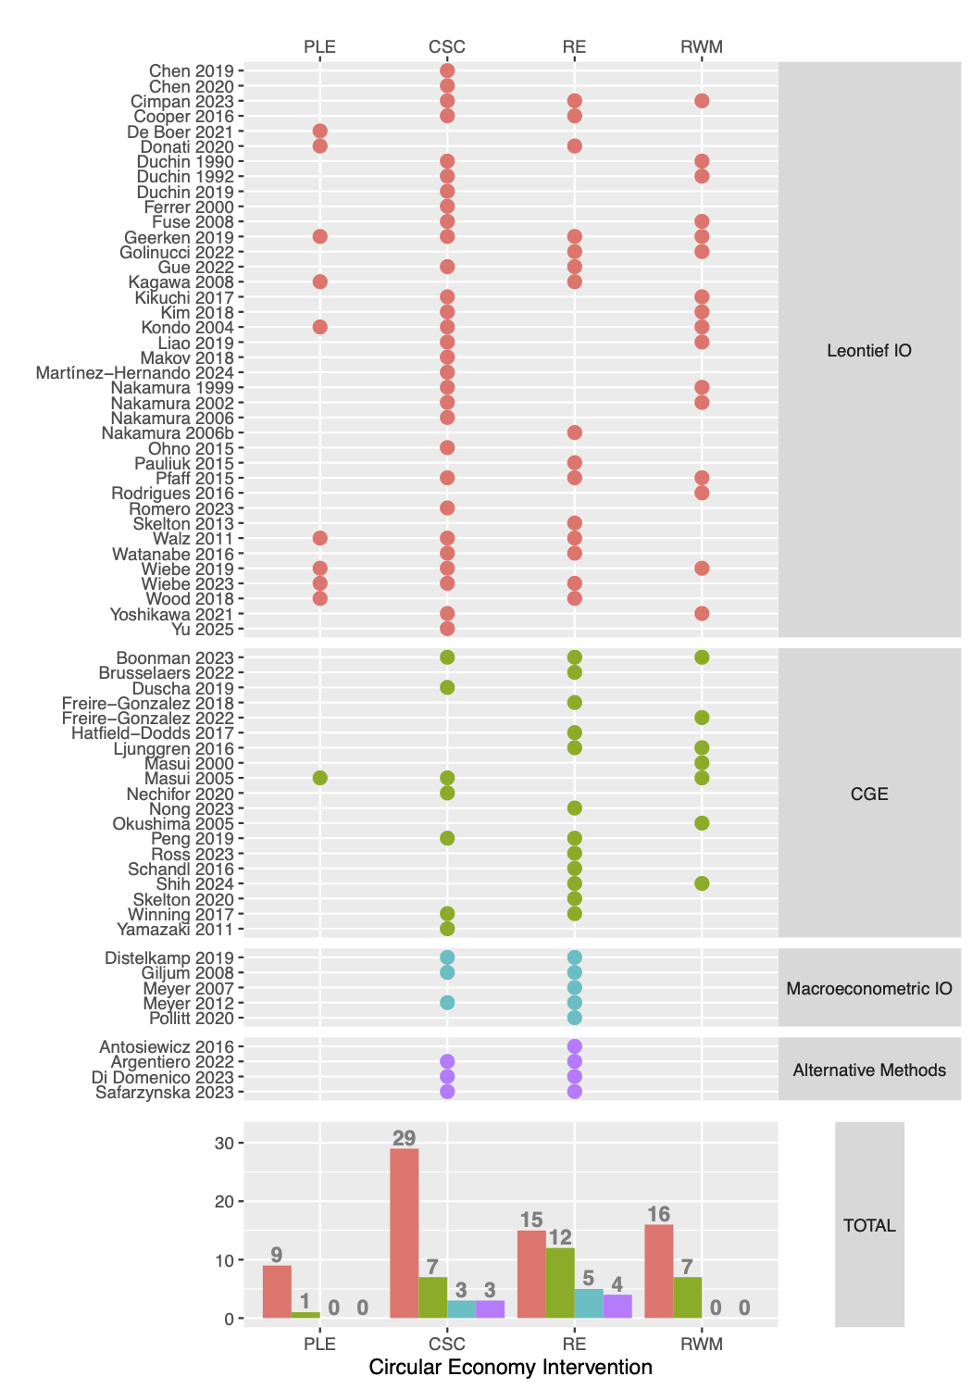

Figure A2: Evolution over time of the 77 selected published articles by method (top row) and the 111 published circular economy interventions (bottom row). Simple (left) and cumulative (right) count; total in dark grey; numbers differ as an article can address multiple CE strategies

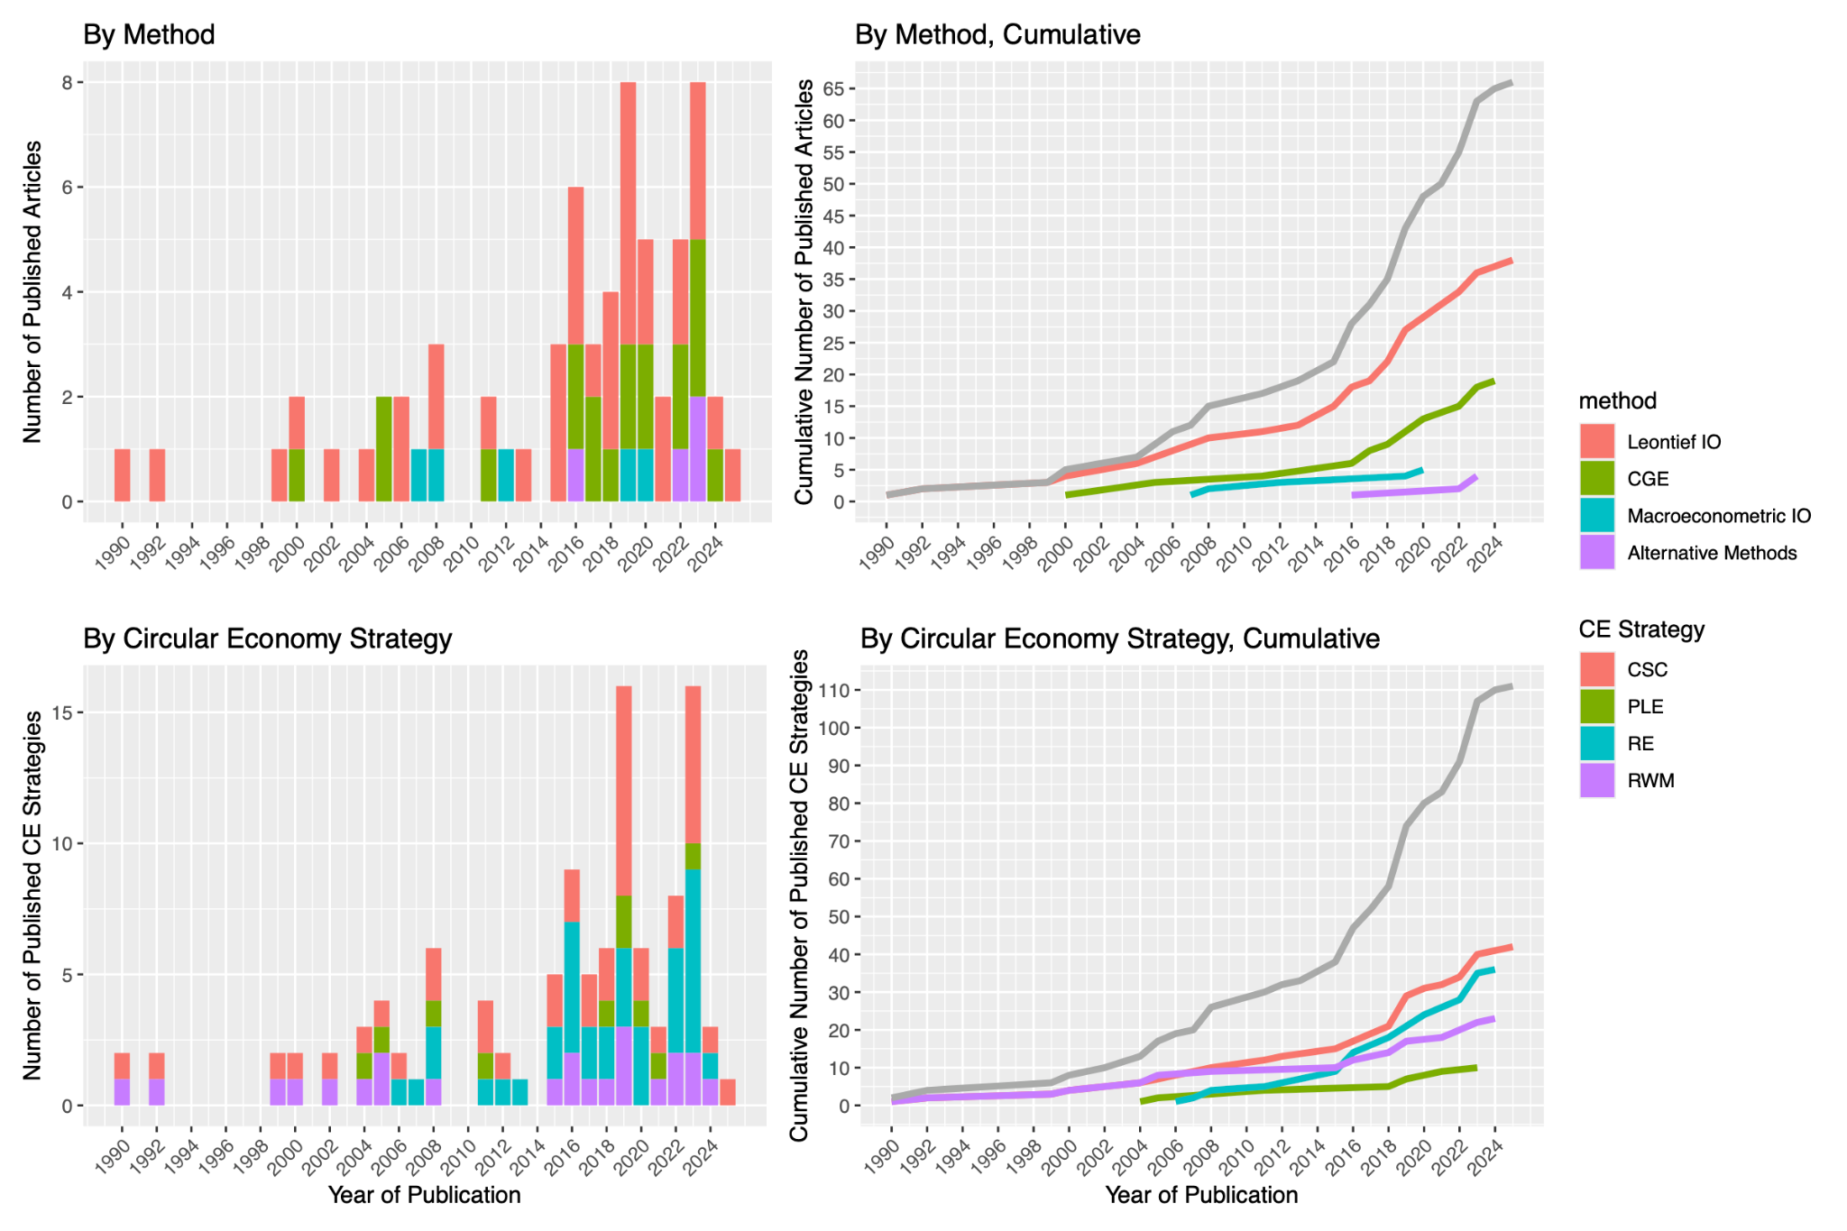

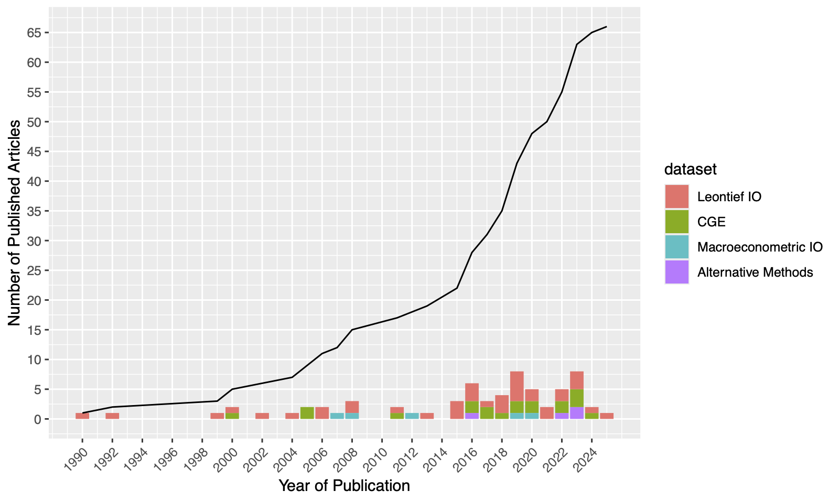

**Figure B: Leontief IO Summary**

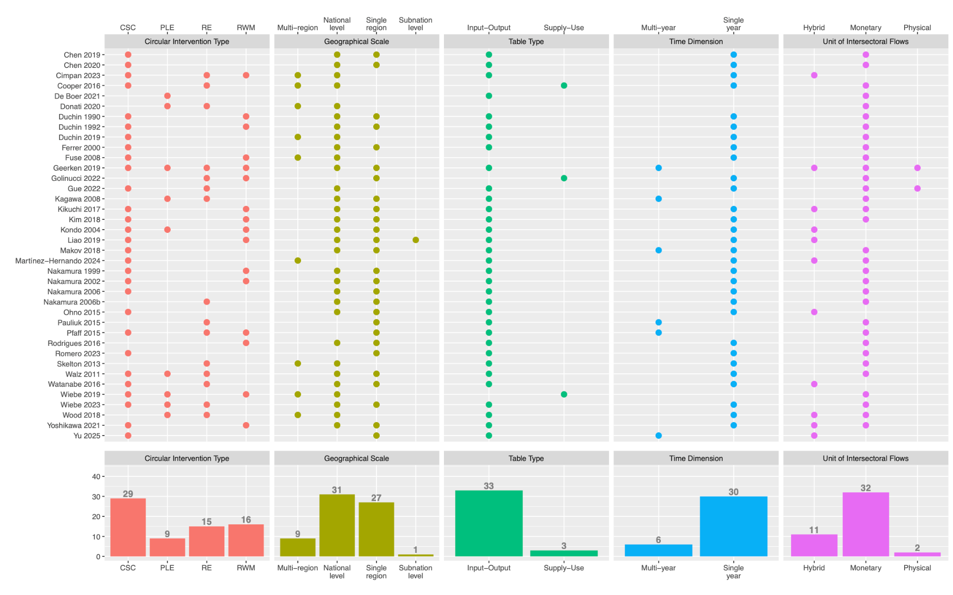

1. A discussion on the usage of the terms intervention versus strategy with reference to Aguilar-Hernandez et al.’s (2018) categories is provided by Donati et al. (2020). We have opted to adopt the terminology of the latter, with strategies referring to a broad category of intervention types.
2. At the time of writing, over 40 projects reference the Circular Economy Action Plan within their Project Description as listed on the CORDIS database.
3. Future research on expanding the typology used in Aguilar-Hernandez et al. (2018) would be useful. Indeed the significant overlap between categories once we start reflecting into the specific interventions, which blur divisions. For instance, it is debatable whether remanufacturing and re-use should be classified as closing supply chains or product life-extension. We thank one of the anonymous referees for raising these issues.
4. The small number of alternative methods identified include dynamic stochastic general equilibrium (DSGE), agent-based modelling (ABM) and stock-flow-consistent (SFC) modelling. Not representing a unified body of literature, they are briefly discussed in Section 4.
5. Leontief IO models are typically described as ‘open’ (/‘closed’) models depending whether there is not (/is) feedback from changes in income components (wages, profits, taxes) to changes in domestic final demand components (investment, household and government consumption). See Miller and Blair (p.34, 2009) for further differentiation.
6. Technology is defined by technical and labour coefficients, which are calculated, respectively, as the quantities of material inputs and labour units necessary to produce one unit of output in each sector.
7. Additionally In multi-regional applications, exchange rates are assumed to be fixed.
8. Rebound effects are observed when introduction of more resource-efficient technologies leads to more, rather than less, resource use (Sorrell & Dimitripoulos, 2008; Sorrell et al, 2009).
9. A detailed classification of the CGE models can be found in the Supplementary Information file.
10. Or firms must possess some degree of market power to set prices higher, without facing reduction in demand (inelastic demand).
11. Schandl et al. (2016) and Ngong et al. (2023) also use the same assumption of costless efficiency gains in the use of material inputs.
12. The SFC approach offers a systematic framework for the dynamical analysis of the complex institutional structure of whole socio-economic systems, using 1) careful, rigorous double-accounting of all stocks and flows through extended social accounting and flow-of-funds matrices, and 2) sets of behavioural equations, often post-Keynesian (Godley & Lavoie, 2006; Caverzasi & Godin, 2015; Nikiforos & Zezza, 2018). Adding flow-of-funds accounts to the social accounting matrices conventionally used by in CGE modelling, the main contribution of the earliest SFC models was their consistent and comprehensive integration of the flows and the stocks for both the real and the financial sides of the economy, which allowed them, unlike conventional macroeconomic models, to successfully anticipate both the 2008 Global Financial Crisis and the 2010-12 Eurozone sovereign debt crisis (Godley & Lavoie, 2006). In the pressing context of the climate crisis, the SFC approach is particularly well-suited to capture the complex dynamic interactions between the environment and the economy (Jackson & Victor, 2015; Fontana and Sawyer, 2016 Dafermos et al., 2017; Carnevali et al, 2021; Cieplinski et al, 2021; Jackson & Jackson, 2021; Canelli et al, 2024). Unlike conventional macroeconomic models, SFC models belong to the broader family of system dynamics (Forrester, 1961; D’Alessandro et al, 2020), of widespread use in the natural sciences and engineering, thus featuring a natural treatment of economic dynamics.
13. Agent-Based Modelling (ABM) was originally applied in economics to model topics of competition and market dynamics (Holland and Miller, 1991; Tesfatsion, 2003; Page, 2008; Dosi et al, 2010), as well as innovation and technological progress (Nelson and Winter, 1985; Dosi and Nelson, 2010). ABMs have also been more recently applied more specifically to stock-flow consistent macroeconomics (Caiani, 2016) and topics related to the energy transition (Hoekstra et al. 2017). Attempts to combine it with Input-Output analysis have also been recently performed by Poledna et al. (2023) and, very successfully, at the micro-level of the enterprise searching for dynamic pathways towards industrial symbiosis within the broader context of the circular economy (Albino et al, 2016; Fraccascia et al, 2019; Fraccascia et al 2020; Yu et al 2021).